Student
Financial
Awards
2023-24

A copy of this book can be found on the School District website:
www.sd42.ca under the student tab

TABLE OF CONTENTS |  |  | Page No.
Acknowledgment |  |  | 5
Board Policy and Introduction |  |  | 6
Other Awards Information |  |  | 7
BC Ministry of Education Scholarships/Awards |  |  | 7
District Authority Scholarship |  |  | 8
Maple Ridge - Pitt Meadows School District Awards Information |  |  | 10
District Award Categories |  |  | 11
Award No. |  | Awards (By Category)
Category A
BURSARY AWARDS
A | 1 | Auxiliary to Ridge Meadows Hospital and Health Care Centre Bursary | 12
A | 2 | Board of Education – Bursaries | 12
A | 3 | Dean C. Froese Memorial Fund | 12
A | 4 | Dr. Biju Matthews Bursary | 12
A | 5 | J.M. Suddaby Scholarship | 13
A | 6 | John Huffman Memorial Bursary | 13
A | 7 | Ken Worely Memorial Bursary for Trades | 13
A | 8 | Karina LeBlanc Foundation Bursary | 13
A | 9 | Melva Leppa Bursary | 14
A | 10 | Michael Hickey Memorial Bursary | 14
A | 11 | Newcomer Bursary | 14
A | 12 | Ridge Meadows Hospital Emergency Physicians Bursary | 14
A | 13 | Ridge Meadows Medical Association Bursary | 15
SCHOLARSHIP AWARDS
A | 14 | Colin Wyllie Memorial Scholarship | 15
A | 15 | DPAC (SD No 42) Scholarship | 15
A | 16 | Fraser Regional Correctional Centre Scholarship | 15
A | 17 | Gary and Nanette Lycan Scholarship | 15
A | 18 | Justice Scholarship | 16
A | 19 | Keane Hauzer Scholarship | 16
A | 20 | Maple Ridge Community Foundation - 20th Anniversary Scholarship | 16
A | 21 | Maple Ridge Community Foundation - Dr. Robert C. Rhodes Scholarship | 17
A | 22 | Merv Smith Memorial Scholarship #1 | 17
A | 23 | Merv Smith Memorial Scholarship #2 | 17
A | 24 | Mountain West Studios Scholarship | 17
A | 25 | Ridge Meadows Medical Association Scholarship | 17
A | 26 | Susan Van Pelt Memorial Scholarship | 17
A | 27 | Thelma Greenwell Memorial Scholarship | 18
A | 28 | Wes Durksen Memorial Scholarship | 18
OTHER AWARDS
A | 29 | Danielle O’Gorman Award | 18
A | 30 | Maple Ridge Community Foundation - George Mussallem Vocational Education Opportunity | 18
A | 31 | Mihika Artistic and Academic Achievement Award – Mihika Foundation | 18
A | 32 | Rob Jeeves Community Scholarship Fund | 19
A | 33 | Ridge Meadows Recycling Society’s Environmental Studies Award | 19
Category B (By Schools)
GARABALDI SECONDARY SCHOOL
B | 1 | Gordon Hausknecht Award | 20
B | 2 | Grant De Patie Memorial Endowment Fund Bursary | 20
B | 3 | McLean Family Trust Fund | 20
B | 4 | Phil Condon – Dr. L.C. Steindel Memorial Bursary | 20

MAPLE RIDGE SECONDARY SCHOOL
B | 5 | Brian Hestermann Memorial Scholarship | 21
B | 6 | Cindy Thompson Award | 21
B | 7 | H.L. Draper Scholarship | 21
B | 8 | Kevin Varga Inspiration Award | 21
B | 9 | Mathew Hall Memorial Bursary | 20
B | 10 | Shiksha Foundation Scholarship – Mihika Foundation | 22
B | 11 | Phoenix Award | 22
B | 12 | Taylor Hart Memorial Award | 22
PITT MEADOWS SECONDARY SCHOOL
B | 13 | Free Agents Family Award | 22
B | 14 | Kendra Nicole Harris Memorial Scholarship | 22
B | 15 | Lois Russell Memorial Bursary | 23
SAMUEL ROBERTSON TECHNICAL SCHOOL
B | 16 | Ali Mosdell Memorial Bursary | 23
THOMAS HANEY SECONDARY SCHOOL
B | 17 | Grant De Patie Memorial Endowment Fund Bursary | 23
B | 18 | Jordan McIldoon Memorial Award | 23
WESTVIEW SECONDARY SCHOOL
B | 19 | Colin Parke Memorial Scholarship | 24
B | 20 | Lance Rossington Humanitarian Award | 24
B | 21 | Shannon Raymond Memorial Bursary | 24
Category C
BURSARY AWARDS
C | 1 | Jacob Family Bursary | 25
C | 2 | James Cameron School Bursary | 25
C | 3 | Kiwanis Club of Golden Ears Bursary | 25
C | 4 | Paul Dwillies and Bernice Gehring Bursary | 26
C | 5 | Pitt Meadows Lion’s Club Bursary | 26
C | 6 | Royal Canadian Legion Bursary Program | 26
C | 7 | Royal Canadian Legion Ladies Auxiliary Branch #88 Bursary | 26
C | 8 | Stardom Childcare Bursary | 27
C | 9 | WomanCare Courage Award | 27
SCHOLARSHIP AWARDS
C | 10 | Andrew Wilhelm-Boyles Award | 27
C | 11 | CUPE – Local 622 Scholarship | 28
C | 12 | Golden Ears Athletics Scholarship | 28
C | 13 | IAFF Local 323 Madeline Stroup Memorial Award | 28
C | 14 | Kabuya Family Salt n Sear Scholarship | 28
C | 15 | Meadow Ridge Rotary – Post Secondary Education Bursaries for Graduation Year 2022/23 | 29
C | 16 | The ACT Careers in Arts Awards | 29
C | 17 | Uplan Award | 30
Category D
BURSARY AWARDS
D | 1 | Beta Sigma Phi Bursary | 30
D | 2 | Blue Mountain Elementary PAC Bursary | 31
D | 3 | Demarrage Bursary | 31
D | 4 | Kanaka Creek Parent Advisory Council (PAC) Bursary | 31
D | 5 | Maple Ridge Teachers’ Association – Bursaries | 31
D | 6 | Maple Ridge Teachers’ Association – Bursary (Education) | 32
D | 7 | Pacific Eye Doctors Clinic – Bursary | 32
D | 8 | Ridge Meadows Association for Community Living Bursaries #1 | 32
D | 9 | Ridge Meadows Association for Community Living Bursary #2 | 32
D | 10 | Ridge Meadows Minor Hockey Association Bursary | 32
D | 11 | Ridge Meadows Minor Softball Association Bursaries (In memory of Don Allen) | 32
D | 12 | Rotary Club of Haney - Academic Bursary | 33
D | 13 | Rotary Club of Haney - Apprenticeship and Trades Bursary | 33
D | 14 | Rotary Club of Haney – The Ken Eis Memorial Bursary | 33
D | 15 | Rotary Club of Haney – Arts Bursary | 33
D | 16 | Sandhurst Properties Inc. (Dewdney ESSO Tim Horton's) Bursary | 33
D | 17 | Sandhurst Properties Inc. (Tim Horton's Dewdney Trunk & 230th Street) Bursary | 33
D | 18 | Whonnock Community Association Bursary | 34
SCHOLARSHIP AWARDS
D | 19 | Aiden Serr Memorial Scholarship | 34
D | 20 | Fitness Unlimited Athletic Club Scholarship | 34
D | 21 | Joyce Osborne Memorial Scholarship | 34
D | 22 | Maple Ridge Teachers’ Association – Greta Hare Scholarship (includes other districts) | 34
D | 23 | Maple Ridge Teachers’ Association – Paul Bondar Scholarship (includes other districts) | 35
D | 24 | Pacific Eye Doctors Clinic – Scholarship | 35
D | 25 | Ridge Meadows Minor Baseball Association Scholarship | 35
D | 26 | The RMMHA Jim Lindsay Memorial Scholarship | 35
OTHER AWARDS
D | 27 | CUPE – Local 703 Awards | 36
D | 28 | CUPE – Local 703 Ron Anderson Memorial Award | 36
D | 29 | Maple Ridge Elementary PAC Award | 36
Category E
E | 1 | Education Dream Fund Awards | 37
E | 2 | Philip Cooper Woodworkers Award | 37
E | 3 | Tenho Katainen Memorial Scholarship | 37

Appendices | Forms / Applications
A | School District No. 42 Scholarship/Bursary Application Package Information | 38
B | School District No. 42 Scholarship/Bursary Application | 39
C | Bursary Financial Information Form | 40
D | CUPE Local 703 Award Application Form | 41
E | Whonnock Community Association Bursary Application Form | 42
F | Maple Ridge Teachers’ Association Bursary (Education) Application Form | 43
G | Maple Ridge Teachers’ Association Bursary Application Form | 44
H | UPlan Application Form | 45
I | Royal Canadian Legion Ladies Auxiliary Branch #88 Application Form | 46
J | James Cameron Application Form | 48
K | Kiwanis Club of Golden Ears Application Form | 51
L | WomanCare Courage Award Application Form | 52
M | Gary and Nanette Lycan Scholarship Application Form | 55
ACKNOWLEDGMENT

Students,
On behalf of the Maple Ridge-Pitt Meadows Board of Education, I would like to congratulate you on reaching this important milestone on your education journey. You are stepping out into a world that has just come through a once-in-a-lifetime shift and is therefore, full of opportunities.
I would like to take this opportunity to thank the many local service groups, organizations, and individuals who contribute funding to help financially support you in the next years of your education. The large number of scholarships and bursaries in this book highlights the wishes of so many in our community to invest in you and all our youth.
I hope you will take the time to read about each contributor, hear their stories, and most importantly, acknowledge and thank them for their investment in you and your future.
We are looking forward to hearing about your future successes.
Best wishes,

Elaine Yamamoto, Chair
School District 42 - Board of Education

To the Graduating Class of 2023/2024
The 2023-2024 district scholarship booklet exemplifies the strong connection our community has forged with students in the Maple Ridge – Pitt Meadows School District. You are in the thoughts of many generous individuals, businesses, and local organizations who want to assist you in achieving your goals. Whether you plan to attend university, pursue a career in the trades, enroll in college, or take advantage of other forms of learning, you will find support for your pathway in this community.
I encourage you to apply for the bursary and scholarship opportunities described in this booklet. If you are fortunate enough to receive financial support, please write the donor to express your gratitude. Keep in mind that many of the community members supporting you today were at one time in need of similar community assistance to achieve their goals. We hope that should you be fortunate to get the opportunity, you too will support students in need later in your life.
We wish you well as you move forward with your post-secondary plans. We are very proud of you and hope that you continue to stay connected to our school district and community.
Best wishes to all of you!

Harry Dhillon
Superintendent of Schools

MAPLE RIDGE – PITT MEADOWS SCHOOL DISTRICT NO. 42
STUDENT FINANCIAL AWARDS
2023-2024
Philosophy of SD42 Selection Committees
Scholarship / Bursary / Award

BOARD POLICY: SD 42 POLICY: 4435
The Board of Education (“Board”) encourages students to pursue school programs to stimulate their levels of thought, productivity and citizenship. All student scholarships, bursaries and awards presented in the School District shall be granted strictly on the merits of the recipient and criteria determined by the donor/organization of the award.

The Board is appreciative of the community support given to students and encourages members of the public and community organizations to support the students of the School District by donating funds for scholarships, bursaries and awards.

In keeping with the Board’s policy it has been the approach of the selection committees, both District and school based, to recognize as many of the outstanding accomplishments of as many students from SD42 that meet the criteria set out in the award description. As such, in cases where a student may meet the criteria of a number of awards, prior to awarding multiple awards to a single student, the selection committees will ensure that all applicants demonstrating outstanding accomplishment in meeting the criteria are considered. In this way, we are able to recognize as many of the outstanding students in our district as possible. However, if the accomplishments of a student are of such an outstanding nature as to set them significantly apart from all other’s in meeting the criteria then the committees shall award accordingly. It is important to recognize as many of our outstanding students as possible.

INTRODUCTION:
A number of types of financial assistance are available to students for post-secondary education and/or training:
SCHOLARSHIPS: A monetary value given to a student in recognition of academic achievement and may include, but is not limited to, financial need and qualities or performance deemed important by the donor (e.g. volunteer service, community involvement, leadership, etc.).

BURSARIES: A monetary value given to a student based on demonstrated financial need and a minimum of satisfactory academic standing. Additional selection criteria may also be used.

AWARDS: A monetary or other value presented to a student in recognition of qualities or performance deemed important by the donor (e.g. volunteer service, community involvement, leadership, etc.) and may include but is not limited to academic achievement or financial need.

If you are planning on attending a post-secondary institute, be sure to contact their financial aid office for assistance. They can provide excellent, up to date information to help you get the money you need. Discuss with your school representative(s) the method of application. Pay special attention to the deadline dates for applications. Many of these awards must be applied for early. Additional information is available on the following websites:

BC Ministry of Education www.bced.gov.bc.ca/awards
Student Aid BC https://studentaidbc.ca/
Scholarships Canada http://www.scholarshipscanada.com/

NOTE: Students will have two (2) years from the date of issue to redeem an award, unless otherwise stated.

OTHER AWARDS
Please refer to the School District website at www.sd42.ca under the following tabs, “Students”, “Student Scholarships”, “Other Scholarships and Bursaries”; for other award opportunities that are not included in the School District 42 Student Financial Awards booklet.
BC MINISTRY OF EDUCATION AND CHILD CARE SCHOLARSHIPS / AWARDS
All Provincial scholarships will be vouchers that can be used to be reimbursed by the Ministry of Education and Child Care for tuition paid after they are attending an designated post-secondary institution or B.C. authorized trades training provider and/or approved K-12 teacher education program in B.C.
BC EXCELLENCE SCHOLARSHIP ($5,000 voucher) - Ministry Deadline February 15, 2024 @ 2:59pm PST
Academic: Awarded to 55 high school graduates who have demonstrated service and leadership, both at school and in their communities, and who show aptitude for and commitment to their chosen career or area of post-secondary study.
Payment: Voucher provided by the Ministry of Education and Child Care
Eligibility: For detailed information please refer to the Ministry website at:
Provincial Scholarships Program information for students - Province of British Columbia (gov.bc.ca)
Selection: Recipient/s selected by the Ministry of Education and Child Care

BC ACHIEVEMENT SCHOLARSHIP ($1,250 voucher)
Academic: Recognizing 8,000 graduates with the top academic achievements in the province, based on achievement in Grades 10, 11 and 12 courses used to meet graduation requirements (including electives).
Payment: Voucher provided by the Ministry of Education and Child Care
Eligibility: Students do not apply for this scholarship. If student is eligible, their grades will be automatically considered. For detailed information please refer to the Ministry website at:
Provincial Scholarships Program information for students - Province of British Columbia (gov.bc.ca)
Selection: Recipient/s selected by the Ministry of Education and Child Care

DISTRICT/AUTHORITY SCHOLARSHIP ($1,250 voucher)
Non-Academic: To acknowledge 5,500 high school graduates who have demonstrated excellence in their chosen area.
Payment: Voucher provided by the Ministry of Education and Child Care
Eligibility: For detailed information please refer to the Ministry website at:
Provincial Scholarships Program information for students - Province of British Columbia (gov.bc.ca)
Selection: Recipients selected by Individual School Scholarship Committee
More Information provided on page 8 of this booklet

PATHWAY TO TEACHER EDUCATION SCHOLARSHIP ($5,000 voucher) - Ministry Deadline February 15, 2024 @ 2:59pm PST
Non-Academic: Awarded to 20 outstanding high school graduates who have demonstrated a commitment and aptitude for a career path in K-12 teaching.
Payment: Voucher provided by the Ministry of Education and Child Care
Eligibility: For detailed information please refer to the Ministry website at:
Provincial Scholarships Program information for students - Province of British Columbia (gov.bc.ca)
Selection: Recipient/s selected by the Ministry of Education and Child Care

Information on the above scholarships is available at https://www2.gov.bc.ca/gov/content/education-training/k-12/support/scholarships/provincial-scholarships

NOTE: Students may apply for and win both a BC Achievement Scholarship and a District/Authority Scholarship.

DISTRICT/AUTHORITY SCHOLARSHIP

Provided by the Ministry of Education and Child Care – Selected by the individual School Scholarship Committees
There are 5,500 District/Authority Scholarships distributed across school districts and independent school authorities that recognize graduating B.C. students who have demonstrated excellence in their chosen area. Winners will receive a $1,250 scholarship voucher to use towards their post-secondary tuition.

Eligibility Requirements – to be eligible for the Provincial Scholarships Program, you must:
- Be a Canadian citizen or a permanent resident (landed immigrant) at the time of registration in the school year for which the scholarship is awarded.
- Be a B.C. resident.
- Be or have been In the school year for which the scholarship is awarded:
- Enrolled in a British Columbia public school (including Distributed Learning schools), or
- Enrolled in a Group 1,2, or 4 British Columbia Independent School, or
- Enrolled in a Continuing Education Centre, or
- Registered with a public, independent, francophone or distributed learning school in B.C. as a
homeschooled child;
- Be graduating in the same year the scholarship was awarded (by August 31)
- Meet the selection criteria for each scholarship
Application Process
Students should contact their school for details about scholarship criteria and application process. Students must apply directly to their school scholarship committee. A student must meet criteria determined by the local scholarship committee, which requires students to demonstrate outstanding achievement in any of the following areas:
- Indigenous Languages and Culture, demonstrated at school or in the community
- Fine Arts (Visual Arts, Dance, Drama, Music)
- Applied Design, Skills, and Technologies (Business, Technology, Home Economics, Media Arts, Tourism)
- Physical Activity and Health (Athletics, Dance, Gymnastics)
- Languages (External Assessments or Languages Curriculum, including AP and IB courses)
- Community Service /Volunteer Activity (includes awareness of local, global, and cultural issues)
- Technical and Trades Training (Mechanics, Robotics, Coding, Woodwork, Culinary Arts)

Guidelines
- Criteria, application forms, and selection processes should be consistent among schools within a school district/independent school authority.
- Information about selection criteria and process should be posted on the district/authority web site.
- Applications must include evidence of student learning or achievement in the chosen area of interest and may include but are not limited to:
- Submission of a project/portfolio (electronic or hardcopy), display or video
- Participation in an interview, performance or demonstration.
4. In addition to an application form, applications may include a selection of the following components:
- Reference letters or recommendation forms from teachers or community sponsors;
- Resume;
- Unofficial transcript;
- Written statement of application or essay, outlining motivation for pursuing area of interest, impact of this involvement, highlights of achievement, personal/educational goals in this area and plan for attaining these goals; and
- Evidence of other attributes such as, creativity, innovation, initiative, motivation, leadership, cooperation, good citizenship in school/community, attendance, punctuality, work habits.
- Applications should be adjudicated by a committee, either at the district/authority or school level, as appropriate. Committee members may include but are not limited to:
- Teachers
- School administrators
- Superintendent of Schools or designate
- School Trustees
- Parent Advisory Council representatives
- Municipal Council representatives
- Local business representatives
- Community representatives
Selection Procedure
Each school scholarship committee will select, using their own criteria, and bearing in mind the Eligibility Requirements and Specific Procedures and Rules, the best candidates to make presentations to the School Scholarship Committee. The number of candidates to make presentations will be determined by the school.

Redeeming all Ministry of Education and Child Care Vouchers
Students have 5 years to redeem their Ministry voucher. The expiry dates are printed on the vouchers and extensions are not possible.

Please follow the link below for information on redeeming your voucher.

Redeeming your Voucher

MAPLE RIDGE - PITT MEADOWS SCHOOL DISTRICT AWARDS
Scholarships, Bursaries and Awards sponsored by organizations and individuals within the Maple Ridge-Pitt Meadows School District No. 42 exclusively for students in District No. 42. To be eligible the student must have taken at least one course in their graduating year with School District 42.

NOTE: Students will have two (2) years from the date of issue to redeem an award, unless otherwise stated.

1. Graduating students may apply for one or more of these awards, providing they meet the qualifications set forth by the organization granting the award. Please check the qualifying details for each award. Please note:
- The scholarship is available to members of the graduating class (Grade 12) of secondary schools who are ordinarily resident in British Columbia.
- A student must have a Social Insurance Number.
2. Applications are to be made on School District No. 42 Scholarship / Bursary application form (Appendix B, C) unless otherwise noted.
3. Applicants must complete one application package for each award applied for. If the applicant is applying for 6 awards, then 6 application packages must be completed unless otherwise noted.
4. The personal statement of application (one and one-half page maximum, 1.5 spaced) should contain the following:
a) if the award requires special qualifications, state clearly how you qualify.
b) a short statement of your goals in pursuing post-secondary education and proposed program.
c) a brief outline of your interests, hobbies, and activities in the school and in the community.
d) employment and/or volunteer activities (past two years).
e) information concerning prizes, scholarships, or awards already won (if any) and in what field.
5. To receive bursary or scholarship monies, students will be required to provide a Social Insurance Number.
6. For applicable awards (see award criteria), no financial payment will be made until student’s proof of payment of tuition is received by the paying/awarding agency.
7. Students who apply to multi-organizations should be cautioned that some organizations do not allow students to win more than one scholarship or bursary. Please check with the organizations, especially ones not represented in the booklet.
8. Each school will identify their own deadline for applications to be submitted to their school representative(s).
9. All applications must be submitted by the school to the District Education Office. The District Office will not accept ANY applications hand delivered by the student or other persons.
10. Information submitted in the application packages may be sensitive in nature. In signing Appendix B, student’s submitting applications to the District Scholarship Committee and individual School Awards Committee understand and agree to the collection, use and disclosure of their personal information for the purpose of evaluating and proofing applications for scholarships and/or bursaries. Further, student’s also understand and agree to the information in the packages being disclosed, as appropriate, with Committee members including but not limited to:
a) Teachers
b) School administrators
c) Superintendent of Schools or designate
MAPLE RIDGE - PITT MEADOWS SCHOOL DISTRICT
AWARD CATEGORIES

Category A: District Education Office (DEO)
Selected by: District No. 42 Awards Committee
Apply to: Secondary School Representative(s)
Deadline: Refer to Individual School Deadline

Category B: School Selection Committee (results forwarded to DEO)
Selected by: Individual School Awards Selection Committee
Apply to: Secondary School Representative(s)
Deadline: Refer to Individual School Deadline

Category C: Direct to the Organization
Selected by: The Organization
Apply to: Directly to the organization listed
Deadline: Date indicated by the organization

Category D: Schools Submit to DEO – please read the criteria carefully
Selected by: The Organization
Apply to: Secondary School Representative(s)
Deadline: Refer to Individual School Deadline

Category E: Specific Criteria – please read the criteria carefully
Selected by: As indicated
Apply to: As indicated
Deadline: As indicated

PLEASE NOTE:

* Check the application submission requirements carefully to ensure:
- you fully meet the criteria as identified
- your application is submitted to the correct location
- your application is submitted by the submission deadline date.

* Unless otherwise stated please submit your application to your school representative(s).

* Deadline dates:
- all Category A, B, D and E applications must be submitted by the school to the District Education Office, please check with your school representative/s for the submission deadline date.
- All Category C applications must be submitted directly to the organization by the date indicated by the organization
- Check all deadline dates carefully.

PLEASE ENSURE YOU FULLY MEET THE CRITERIA BEFORE SUBMITTING ANY APPLICATION

Category A: District Education Office (DEO)
Selected by: District No. 42 Awards Committee
Apply to: Secondary School Representative(s)
Deadline (School): Date indicated by the school – Check with your School Representatives

BURSARY AWARDS – Complete Appendix C and include with Application Package
A1 Award: Auxiliary to Ridge Meadows Hospital and Health Care Centre Bursary
Value: 2 at $500
Eligibility: Grade 12 graduating student of a SD No. 42 Secondary School with a future in the medical field
Criteria: a) must be a bona fide resident of Maple Ridge or Pitt Meadows
b) recipients must be proceeding to post-secondary studies/training in a Health Care related field at
an accredited university or equivalent institution in British Columbia
c) bursary must be claimed within 18 months from the September of the year it was awarded
d) The School District Scholarship Committee will select the recipient of the bursaries
Payment: School District No. 42: 22225 Brown Avenue, Maple Ridge, BC V2X 8N6

A2 Award: Board of Education Bursaries
Value: 8 at $500 (1 per secondary school, 1 Riverside, 1 Connex)
Eligibility: Grade 12 graduating student of a SD No. 42 Secondary School
Description: Each year, the Board establishes an operating funding allocation to support issuing awards to one
graduate of each secondary school.
Criteria: a) the academic achievement of the applicant
b) the non-academic qualities or performance of the applicant (e.g. volunteer service, community
involvement, leadership, financial means, etc.)
To claim: Recipient must provide proof of enrolment into post-secondary schooling
Payment: School District No. 42: 22225 Brown Avenue, Maple Ridge, BC V2X 8N6

A3 Award: Dean C. Froese Memorial Fund
Value: 1 at $750
Eligibility: Grade 12 graduating student of a SD No. 42 Secondary School
Description: The Dean C. Froese Award was established in 2022 to support students who are pursuing a career in the trades. Dean was a Maple Ridge resident for 25 years and had a passion for supporting youth. Dean was a lead manufacturing operator and cabinet installer. Dean passed away much too young, but his legacy will carry on with the establishment of this award.
Criteria: a) must be a resident of the City of Maple Ridge at the time of graduation
b) open to students proceeding to training in fields related to trades
c) the economic need of the student will be given serious consideration
d) good citizenship is a general requirement
e) applications to include a letter of reference from the school principal or designate (i.e. teacher, VP, counsellor, coach, etc.)
To claim: a) must show proof of registration
b) student is requested to attend a meeting of the Maple Ridge Community Foundation
Payment: Jacquie Montgomery: PO Box 370, Maple Ridge, BC V2X 8K9 604.466.3312 or 604.329.2682

A4 Award: Dr. Biju Matthews Bursary
Value: 1 at $500
Eligibility: Grade 12 graduating student of a SD No. 42 Secondary School
Criteria: a) a student who plans to further their education in Social Justice
b) applicant who shows respect, equality and tolerance of others
c) applicant who has shown interest in Anti-bullying in the school community and community at large
d) financial need would be a factor
Payment: School District No. 42: 22225 Brown Avenue, Maple Ridge, BC V2X 8N6

A5 Award: J.M. Suddaby Scholarship
Value: 1 at $1,000
Description: In recognition of the years of dedication and commitment by Mike Suddaby to the students of Maple Ridge – Pitt Meadows
Eligibility: Grade 12 graduating student of a SD No. 42 Secondary School
Criteria: a) Applicant must have a passion for learning, demonstrated by commitment and perseverance
b) Applicant who faces challenges in being able to continue their post-secondary education
c) Applicant must be achieving above average grades
d) Must include letter of reference/s demonstrating applicants’ determination to meet their goals “against the odds”
Note: A family member will present the award to the recipient at their graduation ceremony
Payment: School District No. 42: 22225 Brown Avenue, Maple Ridge, BC V2X 8N6
Proof of registration/enrolment in a recognized post-secondary institution required

A6 Award: John Huffman Memorial Bursary
Value: 1 at $500
Eligibility: Grade 12 graduating student of a SD No. 42 Secondary School
Criteria: a) a student who plans to proceed to any post-secondary education program
b) first consideration is to a student who is living apart from his/her family for any reason
c) financial need would be a factor
d) involvement in student newspaper/journalism, law, or track and field would be of interest
e) must enclose a letter indicating personal situation and plans for the future.
Payment: School District No. 42: 22225 Brown Avenue, Maple Ridge, BC V2X 8N6

A7 Award: Ken Worley Memorial Bursary for Trades
Value: 1 at $1,000
Description: The award was established to support students who are pursuing a career in Trades
Eligibility: Grade 12 graduating student of a SD No. 42 Secondary School
Criteria: a) Applicant must be taking courses in or planning a career in Trades
b) Applicant must have a good attitude and be a good citizen, must include a letter of reference from a mentor (teacher, counsellor, coach, etc.) stating these qualities
c) Economic need of the applicant will be given serious consideration (Appendix C)
d) Must include a statement indicating personal situation and plans for the future
Note: Donor will present award to recipient at their graduation ceremony
To claim: Must be claimed within 2 years of receiving the award
Payment issued with proof of registration/enrolment in a recognized Trades program or a letter from an employer who is willing to train the applicant.
Payment: KWCC Custom Concrete, Rachel Robichaud 604.961.9747 or admin@kwccontracting.ca

A8 Award: Karina LeBlanc Foundation Bursary
Value: 2 at $2,000
Eligibility: Grade 12 graduating student of a SD No. 42 Secondary School – must be female or identifying as female
Description: Soccer gave Karina, a Maple Ridge graduate, her voice, leading her to become a Unicef Ambassador, UN Ambassador on climate change, Head of Women's football for Concacaf, as well as a world-renowned speaker and motivator. Karina aims to teach youth that leadership means finding one another’s strengths and working together toward a greater purpose; that the power of true and authentic leadership starts with yourself, then connecting on something greater than yourself, with others.
Criteria: a) must be pursuing formal post-secondary education (vocational, technical, academic, apprenticeship)
b) must provide letter of reference from school principal or designate (teacher, VP, counsellor, etc.)
c) applicant must submit a 300 – 500 word essay describing their contribution to school and community through leadership and sports as well as goals for the future
d) economic need of the recipient will be given serious consideration
e) recipient must agree to meet with Karina LeBlanc at a later date for a mentoring session
Note: Applications of proposed recipients will be reviewed by Karina LeBlanc prior to being awarded
To claim: Monies dispersed on proof of payment of tuition fees within a period of two (2) years
Payment: School District No. 42: 22225 Brown Avenue, Maple Ridge, BC V2X 8N6

A9 Award: Melva Leppa Bursary
Value: 8 at $1,250 (1 for each Secondary School, 1 for Continuing Education, 1 for Alternate School)
Eligibility: Grade 12 graduating student of a SD No. 42 Secondary School
Criteria: a) The recipient must demonstrate a commitment to pursue formal post-secondary learning (vocational, technical, academic, apprentice)
b) Applicants must submit a letter describing the goals they hope to pursue through their post-secondary education, their financial need and their involvement in the community or school (athletics, fine arts, leadership, academics, vocational explorations, volunteerism, etc.)
c) A confidential letter of reference from someone other than a parent is required.
d) Preference will be given to students not receiving other non-governmental bursaries.
To claim: Recipients must provide proof of registration in an accredited post-secondary program.
Payment: School District No. 42: 22225 Brown Avenue, Maple Ridge, BC V2X 8N6

A10 Award: Michael Hickey Memorial Bursary
Value: 1 at $1000
Eligibility: Maple Ridge Secondary or Garibaldi Secondary grade 12 graduating students
Description: This bursary was established by friends and family in memory of Michael Hickey, who was a Vice Principal of MRSS and GSS for over 25 years and passed away in 2021. Throughout his life, assisting others to achieve their educational goals was Mike’s passion. This bursary is awarded to a student who demonstrates the same empathy and compassion by selflessly helping others to be successful.
Criteria: a) Attending a recognized post-secondary institution.
b) Requires financial assistance.
c) Academic achievement is not a consideration.
d) Demonstrates a passion for helping others.
Note: MRSS and GSS Award Selection Committees will forward 1 to 2 student applications for the District Scholarship Committee to select from.
To claim: payment issued on proof of payment of tuition for post-secondary
Payment: School District No. 42: 22225 Brown Avenue, Maple Ridge, BC V2X 8N6

A11 Award: Newcomer Bursary
Value: 1 @ $1,000
Eligibility: Grade 12 graduating student of a SD No. 42 Secondary School
Criteria: a) Preference given to refugees or first or second generation immigrants who show financial need
b) Applicants must submit a letter stating how they or their parents arrived in Maple Ridge or Pitt Meadows
c) Applicants must submit evidence of their refugee or first-generation (applicant born outside of Canada) or second generation (at least one parent was born outside of Canada) status.
d) involvement in school, community activities, particularly immigrant-serving activities, will be considered
e) letters of reference should confirm the applicant’s character, service and leadership qualities
Note: Donor will present award to recipient at their graduation ceremony
To claim: Payment issued upon proof of payment of tuition for post-secondary
Payment: School District No. 42: 22225 Brown Avenue, Maple Ridge, BC V2X 8N6

A12 Award: Ridge Meadows Hospital Emergency Physicians Bursary
Value: 1 at $1,000
Eligibility: Grade 12 graduating student of a SD No. 42 Secondary School
Criteria: a) demonstrated a link to Ridge Meadows Hospital (RMH) or Fraser Health Authority; or
b) has a parent who currently works at RMH; or
c) has had a longer term treatment for an illness or medical condition at the hospital; or
d) carried out volunteer work at the hospital
e) is intent to pursue studies in Sciences or Health related fields
f) submit a 1-2 page written essay demonstrating a connection to RMH and intentions for further studies
To claim: recipient must provide proof of enrollment to a post-secondary institution and address of where cheque to be mailed
Payment: Laura Kelly: 11860 – 260th Street, Maple Ridge, BC V2W 2A8 laurajkelly66@gmail.com

A13 Award: Ridge Meadows Medical Association - Bursary
Value: 2 at $1,250
Eligibility: Grade 12 graduating student of a SD No. 42 Secondary School
Criteria: a) graduate student from School District No. 42 with an interest in a Health Care related field
b) recipient must have a financial need
c) recipient to send note to donor of their post -secondary plans
Payment: School District No. 42: 22225 Brown Avenue, Maple Ridge, BC V2X 8N6

SCHOLARSHIP AWARDS
A14 Award: Colin Wyllie Memorial Scholarship
Value: 1 at $500
Eligibility: Grade 12 graduating student of a SD No. 42 Secondary School
Criteria: a) should exemplify school spirit
b) have demonstrated genuine care and consideration for others
c) is planning to attend a recognized post-secondary institution
d) preference will be given to students graduating from Samuel Robertson Technical Secondary and are interested in pursuing a career in Education
e) academic achievement is not a primary consideration.
To claim: Award must be claimed within three (3) years of awarding.
Payment: School District No. 42: 22225 Brown Avenue, Maple Ridge, BC V2X 8N6

A15 Award: DPAC (SD No 42) Scholarship
Value: 1 at $500
Eligibility: SD No. 42 Secondary School grade 12 graduating student who have attended school in SD42 for 5 or more years, one of which must be grade 12
Criteria: a) open to SD No. 42 students of any program
b) must be planning post-secondary education (academic or vocational)
c) good citizenship is a general requirement, a reference letter and contact information from a mentor to be included
d) grades are a consideration, but not a requirement
To claim: must provide proof of enrollment within 18 months or on graduation, to qualify for payment
Payment: School District No. 42: 22225 Brown Avenue, Maple Ridge, BC V2X 8N6

A16 Award: Fraser Regional Correctional Centre Scholarship
Value: 1 at $1,000
Eligibility: Grade 12 graduating student of a SD No. 42 Secondary School
Criteria: a) is a bona fide resident of Maple Ridge
b) recipient must be proceeding to post-secondary studies in the Criminal Justice related field at an accredited university or equivalent institution in British Columbia
c) preference will be given to applicants aspiring to work in the Corrections field
d) economic need of the applicant will be given serious consideration (Appendix C)
To claim: Payment will be issued upon presentation of tuition receipt
Payment: School District No. 42: 22225 Brown Avenue, Maple Ridge, BC V2X 8N6

A17 Award: Gary and Nanette Lycan Scholarship
Description: This scholarship is provided through a generous grant from Mr. Gary Lycan and is administered by the Ridge Meadows Education Foundation (RMEF). One scholarship will be awarded each year to a deserving graduating grade 12 student who wishes to continue their studies in the sciences or science related field at a recognized post-secondary institution. To qualify, the student will have demonstrated outstanding effort and results in their studies, particularly in the sciences.
Value: 1 award for actual tuition up to $6,000 per academic year or $2,500 per semester for full time studies for 5 years leading to an undergraduate degree and up to 3 years leading to a post graduate degree - more information provided on the application form (Appendix M).
Eligibility: SD No. 42 secondary school graduates, a Canadian citizen and permanent resident of Maple Ridge or Pitt Meadows for a minimum of 3 consecutive years immediately prior to graduation.
Criteria: a) Recipient of award will continue their studies in the sciences at a recognized post-secondary institution.
b) Recipient must have demonstrated outstanding effort and results in their studies, particularly in the sciences.
c) Applicant must include a transcript of their Grade 11 and 12 marks.
d) Applicant must include a personal statement about their post-secondary academic goals and long-term career goals (recognizing changes may occur over time).
e) Applicant must provide a minimum of 2 references, at least 1 from a math or science teacher.
Note: Recipient selection will be finalized by the District Scholarship Committee in consultation with a donor representative.
Payment: To claim the first year’s scholarship:
Submit proof of registration in full time studies in a recognized post-secondary institution in the science-based program of your choosing with a receipt of tuition fees paid and/or documentation showing fees required for university admissions, to the following:
Ridge Meadows Education Foundation – c/o 22225 Brown Avenue, Maple Ridge, BC, or contact Ms. Cheryl Ashlie, RMEF Secretary at Cherylashlie@telus.net

A18 Award: Justice Scholarship
Value: 1 at $750
Eligibility: Grade 12 graduating student of a SD No. 42 Secondary School
Criteria: a) Student entering post-secondary education/training in a criminology/justice related field (law, policing,
criminology, etc.)
- Student should demonstrate knowledge of the Jassi Sidhu criminal case by providing a 500-word submission of their research and opinion on the case.
- Preference given to students who have dealt with personal/family issues – Letter of support required.
- If multiple qualified candidates; academic success and/or community involvement will be used to determine most eligible candidate – applicant to provide letter of support with required information.
Payment: Contact Cheryl Ashlie, RMEF Secretary at 604.908.5453 or cherylashlie@telus.net
a) Proof of tuition of post-secondary education/training in required fields required
b) Funds must be claimed within 2 years starting September 1st of the year awarded – if not claimed the
award will no longer be available to the recipient

A19 Award: Keane Hauzer Scholarship
Value: 1 at $500
Eligibility: Grade 12 graduating student of a SD No. 42 Secondary School
Criteria: a) planning to enroll in a carpentry program at a recognized post-secondary institution.
To claim: Must be claimed within 1 year
Payment: School District No. 42: 22225 Brown Avenue, Maple Ridge, BC V2X 8N6

A20 Award: Maple Ridge Community Foundation - 20th Anniversary Scholarship
Value: 1 at $1,000
Eligibility: Grade 12 graduating student of a SD No. 42 Secondary School
Criteria: a) must be a resident of the City of Maple Ridge at the time of graduation
b) open to students proceeding to post-secondary studies or training in fields related to recreation, parks, culture, education, humanities or the environment
c) must provide evidence of volunteer service to the school and/or community

A21 Award: Maple Ridge Community Foundation - Dr. Robert C. Rhodes Scholarship - Established for 25th Anniversary
Value: 1 at $1,000
Eligibility: Grade 12 graduating student of a SD No. 42 Secondary School
Criteria: a) must be a resident of the City of Maple Ridge at the time of graduation
b) the economic need of the student will be given serious consideration (Appendix C)
c) students proceeding to post-secondary studies/training in fields related to medicine or health services
d) must provide evidence of volunteer service to the school and/or community
e) good citizenship is a general requirement, applications should include a letter of reference from the school principal or designate (i.e. teacher, VP, Counsellor, coach, etc.)
To claim: Awards #A20, A21 – Maple Ridge Community Foundation
a) must show proof of registration
b) student is requested to attend a meeting of the Maple Ridge Community Foundation
Payment: Jacquie Montgomery: PO Box 370, Maple Ridge, BC V2X 8K9, 604.466.3312 or 604.329.2682

A22 Award: Merv Smith Memorial Scholarship #1
Value: 1 at $700
Eligibility: Grade 12 graduating student of a SD No. 42 Secondary School
Criteria: a) must be planning to attend a registered post-secondary institution
b) high level of achievement in studies with an emphasis on mathematics and science

A23 Award: Merv Smith Memorial Scholarship #2
Value: 1 at $600
Eligibility: Grade 12 graduating student of a SD No. 42 Secondary School
Criteria: a) must be planning to attend a registered post-secondary institution
b) high level of achievement in studies with an emphasis on mathematics and science
To claim: Awards #A22, A23 – Merv Smith Memorial Scholarship
Payment: Payment upon proof of enrollment in a post-secondary institution
School District No. 42: 22225 Brown Avenue, Maple Ridge, BC V2X 8N6

A24 Award: Mountain West Studios Scholarship
Value: 7 at $500 (1 for each Secondary School, 1 for Connex)
Eligibility: Grade 12 graduating student of a SD No. 42 Secondary School
Criteria: a) planning to attend a recognized post-secondary institution.
b) an interest in photography will be given consideration.
Payment: Mountain West Studios Joeyl@mountainwest.ca or 604-433-0551 Ext. 129

A25 Award: Ridge Meadows Medical Association - Scholarship
Value: 2 at $1,250
Eligibility: Grade 12 graduating student of a SD No. 42 Secondary School
Criteria: a) outstanding academic excellence
b) interested in Health Care related field
c) recipient to send a letter noting post-secondary plans
Payment: School District No. 42: 22225 Brown Avenue, Maple Ridge, BC V2X 8N6

A26 Award: Susan Van Pelt Memorial Scholarship
Description: Susan Van Pelt was with SD #42 for 18 years. She initially worked as a noon hour supervisor and spent her last 9 years as an Education Assistant. She loved kids and volunteered on many occasions. Susan felt the role of the Education Assistant was vital in developing young minds. Her family’s wish is others will follow her career path and in her memory offer this scholarship opportunity.
Value: 1 at $1,000
Eligibility: Grade 12 graduating student of a SD No. 42 Secondary School
Criteria: a) must be pursuing a career as an Education Assistant at a Canadian post-secondary institution
b) first consideration given to students who attended Alouette Elementary for a minimum of 4 years
c) Recipient must agree a copy of their application can be shared with the donor of the award
To claim: Monies disbursed on proof of payment of tuition fees
Payment: School District No. 42: 22225 Brown Avenue, Maple Ridge, BC V2X 8N6

A27 Award: Thelma Greenwell Memorial Scholarship
Value: 1 at $500
Eligibility: Grade 12 graduating student of a SD No. 42 Secondary School
Criteria: a) graduating student who is proceeding to post-secondary studies/training in a field related to home economics, culinary arts, food technology, dietetics, fashion design, early childhood education
b) must be enrolled in a recognized vocational school, college or university
c) must have good character/citizenship and provide evidence of active participation in volunteer services
To claim: Monies disbursed on proof of payment of tuition fees
Payment: School District No. 42: 22225 Brown Avenue, Maple Ridge, BC V2X 8N6

A28 Award: Wes Durksen Memorial Scholarship
Value: 1 at $600
Eligibility: Grade 12 graduating student of a SD No. 42 Secondary School
Criteria: a) planning to attend a recognized post-secondary institution to become a teacher or professional dedicated to working with children
b) is well respected with a reputation for helping others
c) has overcome a challenge
d) has been a long-time School District No. 42 student
e) has a strong background in music or sports
f) letters of reference to include both the school community and the general community
Payment: School District No. 42: 22225 Brown Avenue, Maple Ridge, BC V2X 8N6

OTHER AWARDS (May require Appendix C)
A29 Award: Danielle O’Gorman Award
Value: 1 at $1000
Eligibility: Grade 12 graduating student of a SD No. 42 Secondary School
Criteria: a) applicants must be going on to post-secondary education
b) applicants have overcome/are working to overcome a significant obstacle or challenge
c) must submit a written paragraph on why they are deserving of this award and how they plan to use it
Note: Recipient will be selected by the District No. 42 Awards Committee with input from Kim O’Gorman
To claim: payment upon proof of enrollment in a post-secondary institution
Payment: School District No. 42: 22225 Brown Avenue, Maple Ridge, BC V2X 8N6

A30 Award: Maple Ridge Community Foundation-George Mussallem Vocational Education Opportunity Fund
Value: 5 at $2,500
Eligibility: Grade 12 graduating student of a SD No. 42 Secondary School who resides in Maple Ridge
Criteria: a) the economic need of the student will be given serious consideration (Appendix C)
b) recipient must enroll in a recognized vocational, technical or trades school or program
c) good citizenship is a general requirement, applications should include a letter of reference from the school principal or designate (i.e. teacher, VP, Counsellor, coach, etc.)
Note: Copies of applications of the recipients will be shared with the donor.
To claim: a) must show proof of registration
b) student is requested to attend a meeting of the Maple Ridge Community Foundation
Payment: Jacquie Montgomery: PO Box 370, Maple Ridge, BC V2X 8K9 604.466.3312 or 604.329.2682

A31 Award: Mihika Artistic, and Academic Achievement Award – Mihika Foundation
Value: 1 at $500
Eligibility: Grade 12 graduating student of a SD No. 42 Secondary School
Criteria: a) Excellence in Academics in the field of science; and
b) excellence in classical music and/or classical dance
c) Must pursue post-secondary education in science or engineering
d) Must be a good, helpful citizen of the community
e) A brief bio about their significant achievements to be included (up to 200 words)
To claim: Recipient must provide proof of enrollment in a science or engineering program
Payment: School District No. 42: 22225 Brown Avenue, Maple Ridge, BC V2X 8N6

A32 Award: Rob Jeeves Community Scholarship Fund
Value: Up to 4 at $500 each
Eligibility: MRSS grade 12 graduating students
Criteria: a) Maple Ridge resident for 3 years or more, including grade 12
b) cover letter outlining a personal vision for their future, including description of how they see themselves being involved in the community, and giving back to their community
c) supporting letter from a teacher or description of charitable organizations student has been involved with (examples of giving back to the community while growing up)
To claim: payment issued upon proof of payment of tuition for post-secondary
Payment: School District No. 42: 22225 Brown Avenue, Maple Ridge, BC V2X 8N6

A33 Award: Ridge Meadows Recycling Society’s Environmental Studies Award
Value: 1 at $2,500
Eligibility: Grade 12 graduating student of a SD No. 42 Secondary School
Criteria: a) Graduating student pursuing environmental studies at a recognized post-secondary institution
b) Applicant to be chosen for demonstrated environmental involvement
c) award to be disbursed within 18 months of winner being announced
d) payment issued on proof of payment of tuition
Payment: Ridge Meadows Recycling: Kim Day, PO Box 283, Maple Ridge, BC V2X 7G2

Category B: School Selection Committee
Selected by: Individual School Awards Selection Committee
Apply to: Secondary School Representative(s)
Deadline (School): Date indicated by the school - Check with your School Representatives

GARIBALDI SECONDARY AWARDS (May require Appendix C)
.
B1 Award: Gordon Hausknecht Award AWARD DETAILS PENDING CONFIRMATION
Value: 1 at $500
Eligibility: Garibaldi Secondary grade 12 graduating student
Criteria: a) student involved with student government
b) demonstrated leadership throughout school.
c) expresses interest in post-secondary education either vocational or academic.
Note: Selection made by Garibaldi Secondary Awards Committee with input from teachers.
Payment: School District No. 42: 22225 Brown Avenue, Maple Ridge, BC V2X 8N6

B2 Award: Grant De Patie Memorial Endowment Fund Bursary
Description: Honoring the memory of Grant De Patie who was killed at an ESSO station in Maple Ridge.
Value: 1 at up to $1,000
Eligibility: Garibaldi Secondary grade 12 graduating student
Criteria: a) will be attending a post-secondary institution immediately after graduation
b) student must have demonstrated a high level of involvement with their school community and
the community at large
c) demonstrated financial need (Appendix C)
Payment: School District No. 42: 22225 Brown Avenue, Maple Ridge, BC V2X 8N6

B3 Award: McLean Family Trust Fund Award AWARD DETAILS PENDING CONFIRMATION
Description: Established in memory of Glynn McLean who attended Garibaldi Secondary School. The award is designed to recognize a student each year who has unselfishly given of themselves to make Garibaldi Secondary and their community a better place during their 3-5 years at Garibaldi Secondary.
Value: TBD
Eligibility: Garibaldi Secondary grade 12 graduating student
Criteria: a) student must be reliable and responsible
b) student must have demonstrated outstanding service to Garibaldi Secondary
c) application must include a letter of nomination from a teacher
Payment: The Winnipeg Foundation: Anna-Maria Pozzi, Student Awards Officer 1.877.974.3631
scholarships@wpgfdn.org

B4 Award: Phil Condon – Dr. L.C. Steindel Memorial Bursary
Description: Established in memory of Phil Condon, an English teacher who taught at Garibaldi Secondary for over 30 years and Dr. L.C. Steindel, whose refusal to submit a bill for substantial services made it possible for the donor to complete university.
Value: 6 at $500 each
Eligibility: Garibaldi Secondary grade 12 graduating student
Criteria: a) must have a high standing on the academic program
b) must be entering university or equivalent
c) have good character and citizenship
d) financial need an important consideration (Appendix C)
To claim: monies disbursed upon proof of payment of tuition fees
Payment: School District No. 42: 22225 Brown Avenue, Maple Ridge, BC V2X 8N6

MAPLE RIDGE SECONDARY AWARDS (May require Appendix C)
B5 Award: Brian Hestermann Memorial Scholarship
Value: 1 at $1,000
Description: Established in 1991 at the request of the parents of the late Brian Hestermann.
Eligibility: Maple Ridge Secondary grade 12 graduating student – male students
Criteria: a) must be taking courses in and planning a career in metal fabrication, auto mechanics or proficient in
music and has the ability to play several instruments.
b) conscientious and hardworking in class
c) considered to be a good citizen
Payment: School District No. 42: 22225 Brown Avenue, Maple Ridge, BC V2X 8N6

B6 Award: Cindy Thompson Award
Value: 1 at $1,000
Description: Cindy Thompson was a teacher whose entire 35 year career was spent at MRSS. For much of this time her passion was teaching literacy and reading to young adults. Cindy’s love for books was always on display and her devotion to English Language Arts is the spirit behind this award.
Eligibility: Maple Ridge Secondary grade 12 graduating student
Criteria: a) In a written passage of 300 words or less the applicant must demonstrate; a passion for reading, a love of learning and involvement in the school
Payment: School District No. 42: 22225 Brown Avenue, Maple Ridge, BC V2X 8N6

B7 Award: H.L. Draper Scholarship
Value: 2 at $1,000
Eligibility: Maple Ridge Secondary grade 12 graduating student
Criteria: a) open to grade 12 students without specification to the particular field of study
b) the economic need of the student will be given serious consideration (Appendix C)
c) must be planning to attend a recognized post-secondary institution
To claim: payment made upon proof of enrollment in a post-secondary institution
Payment: School District No. 42: 22225 Brown Avenue, Maple Ridge, BC V2X 8N6

B8 Award: Kevin Varga Inspiration Award
Value: 1 at $1,000
Description: This award was established by family and friends in memory of Kevin Varga, a graduate of Maple Ridge Secondary. Kevin is remembered as someone who reminds you to laugh, who offers friendship to everyone, who takes initiative to help others, who finds happiness in the little things, and most of all, someone with remarkable strength and determination. The award is designed to recognize a student who has impacted the school community in a positive way.
Eligibility: Maple Ridge Secondary School grade 12 graduating student enrolled at MRSS from grades 10 to 12.
The recipient must exemplify the following aspects of Kevin’s presence in the school:
Criteria: a) Recipient must uphold a positive attitude that impacts others;
b) is committed to the concept of respect and gratitude for others;
c) demonstrates genuine care and consideration for others;
d) exemplifies leadership throughout school;
e) exhibits resilience, determination and perseverance; and
f) plans on attending post-secondary education.
Note: Recipient will be selected by the Maple Ridge Secondary Awards Committee with input from teachers.
Payment: School District No. 42: 22225 Brown Avenue, Maple Ridge, BC V2X 8N6

B9 Award: Mathew Hall Memorial Bursary AWARD DETAILS PENDING CONFIRMATION
Value: 1 at $1,000
Eligibility: Maple Ridge Secondary Outreach grade 12 graduating student
Criteria: a) student must have post-secondary aspirations
b) student must be graduating from Outreach at MRSS
c) student must have a financial need (Appendix C)
Note: Up to 3 eligible recommendations to be selected by teachers of Outreach
Payment: School District No. 42: 22225 Brown Avenue, Maple Ridge, BC V2X 8N6

B10 Award: Shiksha Scholarship – Mihika Foundation
Value: 1 at $1,000 or 2 at $500
Description: Field of Sciences
Eligibility: Maple Ridge Secondary grade 12 graduating student
Criteria: a) demonstrates interests and involvement in sciences e.g. science competitions, courses taken
in high school, and marks and any outside involvement in fields of sciences
b) candidates should have the intent to pursue studies in the sciences at post-secondary
c) statement of main future goals and reasons why they want to pursue studies in the sciences
To claim: Proof of registration in post-secondary is required
Payment: School District No. 42: 22225 Brown Avenue, Maple Ridge, BC V2X 8N6

B11 Award: Phoenix Award AWARD DETAILS PENDING CONFIRMATION
Value: 1 at $1,000
Eligibility: Maple Ridge Secondary grade 12 graduating student (must have documented proof of permanent residency or Canadian citizenship)
Criteria: a) must be grade 12 graduating student who wishes to attend a post-secondary institution
b) documented course(s) in ESL (English as a second language)/English Language Development at the
secondary level (Grades 9 to 12)
c) Demonstrated consistent improvement in academic courses at the secondary level
Payment: School District No. 42: 22225 Brown Avenue, Maple Ridge, BC V2X 8N6

B12 Award: Taylor Hart Memorial Fund
Value: 1 at $2,000
Eligibility: Maple Ridge Secondary grade 12 graduating student or have attended Alouette Elementary School
Criteria: a) must be attending a post-secondary institution in BC in the field of Health Sciences
b) write a few paragraphs explaining why you have chosen this field of studies
c) the economic need of the student will be given serious consideration (Appendix C)
d) good citizenship is a general requirement and applications should include a letter of reference
from the school principal or designate (i.e. teacher, VP, counsellor, coach)
To claim: Must be claimed within two years
Payment: Payment issued upon receipt of tuition paid
School District No. 42: 22225 Brown Avenue, Maple Ridge, BC V2X 8N6

PITT MEADOWS SECONDARY AWARDS (May require Appendix C)
B13 Award: Free Agents Family Award
Value: 2 at $500 (1 Female, 1 Male)
Eligibility: Pitt Meadows Secondary grade 12 graduating student
Criteria: a) Short Essay highlighting the following:
- Good academic standing
- Community involvement (coaching, officiating, assisting seniors, or other volunteer efforts)
- Articulation of core family values
- Career aspirations and goals
Payment: Carrie Coupland at Carri-19@hotmail.com (604.616.3664) or
Riley Dingwall at rileygt@hotmail.com (604.202.7331)

B14 Award: Kendra Nicole Harris Memorial Scholarship
Value: 1 at $500
Description: This scholarship was established in memory of Kendra Nicole Harris. Kendra was a Grade 12 graduate of Pitt Meadows Secondary who passed away on June 28th, 1999. The scholarship, established by family and friends, is in recognition of scholastic achievement in the accounting field. The first year of the scholarship was sponsored by the Meadow Ridge Rotary Club who continue to support the youth of our community.
Eligibility: Pitt Meadows Secondary grade 12 graduating accounting student
Criteria: a) based upon the highest Grade 12 mark in the “accounting” course
b) entering an accredited post-secondary education institution
c) in the event of a tie, degree of involvement in the school community and volunteer time within the community as a whole will be considered
Note: Selection made by Pitt Meadows Secondary accounting teacher
To claim: Monies disbursed on proof of payment of tuition fees
Payment: School District No. 42: 22225 Brown Avenue, Maple Ridge, BC V2X 8N6

B15 Award: Lois Russell Memorial Bursary
Value: 2 at $500 – 1 French Immersion and 1 Academic
Description: Established in the memory of Lois Russell who was a Librarian at Pitt Meadows Elementary.
Eligibility: Pitt Meadows Secondary grade 12 graduating student who attended Pitt Meadows Elementary
Criteria: a) 1 award in the French Immersion Program and 1 in the regular academic program
b) students selected on the basis of achievement and need (Appendix C)
c) not required to enroll in a post-secondary institution
Payment: School District No. 42: 22225 Brown Avenue, Maple Ridge, BC V2X 8N6

SAMUEL ROBERTSON TECHNICAL AWARDS (May require Appendix C)
B16 Award: Ali Mosdell Memorial Bursary
Value: 1 at $1000
Eligibility: Samuel Robertson Technical School (female) graduating student
Criteria: a) student who has demonstrated academic competency & commitment (not necessarily highest marks)
b) student who attended SRT for a minimum of two years
c) involved in athletics in either the community or school
d) demonstrated kindness (not necessarily in leadership clubs/position but rather, presence in the school
in general)
e) preference to student with financial need
Note: selection made by Samuel Robertson Secondary Awards Committee
Payment: School District No. 42: 22225 Brown Avenue, Maple Ridge, BC V2X 8N6

THOMAS HANEY SECONDARY AWARDS (May require Appendix C)
B17 Award: Grant De Patie Memorial Endowment Fund Bursary
Value: 1 at up to $1,000
Description: Honoring the memory of Grant De Patie who was killed at an ESSO station in Maple Ridge.
Eligibility: Thomas Haney Secondary grade 12 graduating student
Criteria: a) student must have demonstrated a high level of involvement with their school community and
the community at large
b) demonstrated financial need (Appendix C)
c) will be attending a post-secondary institution immediately after graduation
Payment: School District No. 42: 22225 Brown Avenue, Maple Ridge, BC V2X 8N6

B18 Award: Jordan McIldoon Memorial Award
Value: 2 at $1,000
Description: This award was established in memory of Jordan McIldoon. He sadly passed away at the age of 23 in 2017. Jordan was a graduate of Thomas Haney Secondary who went on to become a Heavy Duty Mechanic.
Eligibility: Thomas Haney Secondary grade 12 graduating student
Criteria: a) Has overcome a significant obstacle or challenge
b) has overcome adversity or his/her efforts are recognized by teachers
c) requires financial assistance (Appendix C)
d) recipient must enroll in a recognized vocational, technical or trades program
e) a written paragraph outlining why they are deserving of this award and how they plan to use it
To claim: Paid upon proof of enrollment and tuition paid in a vocational, technical or trades focused program
Payment: School District No. 42: 22225 Brown Avenue, Maple Ridge, BC V2X 8N6
WESTVIEW SECONDARY AWARDS (May require Appendix C)
B19 Award: Colin Parke Memorial Scholarship
Value: 1 at $1,000
Description: Established in memory of Colin Parke who was a student of Westview Secondary.
Eligibility: Westview Secondary School grade 12 graduating student
Criteria: a) a student who continues to any post-secondary education program (C- average or above)
b) an interest in music or pursuing a career in music, trades and/or outdoor activities (such as participating in Scouts) will be considered.
c) financial need of the student will be considered (Appendix C)
Payment: School District No. 42: 22225 Brown Avenue, Maple Ridge, BC V2X 8N6

B20 Award: Lance Rossington Humanitarian Award
Value: 1 at $500
Eligibility: Westview Secondary School grade 12 graduating student
Criteria: The award is a school based award for the Grade 12 Humanitarian of the Year in honor of former Westview Secondary VP Lance Rossington.
Note: Graduating students are nominated by staff and the Westview Awards Committee determines the winner
Donor will present at the graduation ceremony
Payment: School District No. 42: 22225 Brown Avenue, Maple Ridge, BC V2X 8N6

B21 Award: Shannon Raymond Memorial Bursary (WSS)
Value: 2 at $250 (1 male, 1 female) OR 1 at $500 if only 1 student meets the criteria
Eligibility: Westview Secondary grade 12 graduating student
Criteria: Each year the Shannon Raymond Bursary is awarded to 1-2 students who have demonstrated a positive presence in the Westview community.
Open to students who:
a) exemplify hard work and perseverance
b) is passionate about sports and committed to team success
c) is upbeat and committed to the concept of respect for others
Note: Selection made by Westview Awards Committee with input from Mrs. Raymond.
Payment: Andrea Humer (Westview Secondary)
20905 Wicklund Avenue, Maple Ridge, BC V2X 8E8

Category C: Direct to the Organization
Selected by: The organization
Apply to: Directly to the organization listed
Deadline: Date indicated by the organization

BURSARY AWARDS – Complete Appendix C and include with Application Package
C1 Award: Jacob Family Bursary
Value: 1 at $500
Eligibility: Grade 12 students with high grades (80%+ average) who have met the graduating requirements and have intention to pursue higher education in Canada. Preference will be given to students who express financial need in their statement.
Criteria: a) Grade 12 student with 80%+ average grades
- intention to pursue higher education – proof of submission application to college/university in Canada required
- volunteer hours (min. 20 hours in past year) with volunteer organization sign off
- 300 word statement from the student on why they deserve this scholarship including their desired program of study in college/university
- Documents to include 300 word statement, transcript, proof of application submission to college/university, volunteer hours with volunteer organization sign-off
Deadline: April 1, 2024
Apply to: Nirmala Jacob at nejacob7@gmail.com
Payment: Contact Nirmala Jacob – as above

C2 Award: James Cameron School Bursary
Description: James Cameron School is a small, independent, accredited elementary school for children with learning disabilities, located in Maple Ridge, B.C. The school was founded in 1980 and is operated by the Fraser Valley Society for Children with Learning Disabilities.
Value: Up to $500
Eligibility: Must be a grade 12 graduating student of a SD42 Secondary school that attended James Cameron School
Criteria: a) has graduated or will be graduating from a secondary school
b) will be attending accredited vocational school, college or university, must provide proof of registration
c) must submit a completed James Cameron School Bursary application package (Appendix J)
d) involvement in school or community activities will also be considered
Deadline: May 1, 2024
Apply to: James Cameron School
Via email at jcsofficeadmin@jcs.bc.ca, or phone 604.465.8444
Payment: James Cameron School, PO Box 157, Dewdney Trunk Road, Maple Ridge, BC V2X 7G1

C3 Award: Kiwanis Club of Golden Ears Bursary
Value: $6000 to be distributed amongst selected recipients in values of $500, $750, $1000
Eligibility: Grade 12 graduating student of a SD42 Secondary school who is a resident of Maple Ridge or Pitt Meadows (separate consideration is given to students who reside outside our cities but attend school in SD42)
Criteria: a) Pursuing post-secondary education at college, university or trade institution, where graduation from grade 12 is a requirement
b) Complete only the Kiwanis Bursary Application Form (Appendix K) and submit a letter (no more than 1 ½ page max and 1.5 spaced) that provides a fulsome picture of your background including all your school and community volunteer service, academic journey, future educational plans and financial situation.
c) Community involvement, particularly service and volunteer work, is dominant consideration
d) financial need, as well as efforts to mitigate financial hardship, also strongly considered
Deadline: April 30, 2024
Apply to: Kiwanis Club of Golden Ears Bursary Committee: PO Box 21173, Maple Ridge, BC V2X 1P7 or email kiwanisofgoldenears@gmail.com
Payment: Payment of bursary issued upon proof of payment of tuition; mail or email to address above.
Note: The bursary must be claimed on or before December 31 of the following year of receiving the bursary (i.e. award received in 2024, must be claimed by December 31, 2025)
C4 Award: Paul Dwillies and Bernice Gehring Bursary
Value: 1 at $250
Eligibility: Grade 12 graduating student of a SD No. 42 Secondary School
Criteria: a) applicant must be applying to part-time or full-time semester at a Canadian registered post-secondary
institution
b) applicant must submit an essay (max 2 pages) detailing their area of study, local community groups
involved/volunteer with (how often, participation) and why they feel it is important to get involved with community groups.
Deadline: April 30, 2024 (5:00pm)
Apply to: The Board of the Fraser North Farmer’s Market Society exec@farmersandmore.org
Payment: Fraser North Farmer’s Market Society exec@farmersandmore.org

C5 Award: Pitt Meadows Lion’s Club Bursary
Value: 2 at $1,000
Eligibility: Pitt Meadows Secondary grade 12 graduating students
Criteria: a) recipient must show a real need for financial assistance
b) must provide references from the school community at large
c) the primary tenet of Lionism is “WE SERVE”. To this extent the recipient must display good
citizenship, leadership in community activities and/or community involvement
d) the successful recipient must maintain a C+ average for Grades 11 and 12
Deadline: March 31, 2024
Apply to: Mr. Dave Campbell, 22763 Balabanian Circle, Maple Ridge, BC V2X 8Z5
To claim: Recipient must provide proof of enrollment in a post-secondary program within 24 months of graduation
Payment: Mr. Chris Young: 11741-194A Street, Pitt Meadows, BC V3Y 1G5 604.465.8223 or c_young@telus.net

C6 Award: Royal Canadian Legion Bursary Program
Value: 6 at $2,000
Eligibility: Grade 12 graduating student of a SD No. 42 Secondary School (children of veterans and ex-service personnel given preference)
Criteria: a) entering a university or equivalent institution within the province of British Columbia
b) entering a vocational school or technological institution within the province of British Columbia
and involves training for which high school graduation is a requirement
c) recipient must not be receiving a large academic or sport related scholarship
d) applicants must provide and complete the following in full or they will not be considered:
- Royal Canadian Legion application form (contact branch for form)
- supporting statements and letters as outlined in application form
e) General information:
- recipient must show a real need for financial assistance
Deadline: May 15, 2024
Apply to: Royal Canadian Legion Branch #88
12101-224th Street, Maple Ridge, BC Phone: 604.463.5101
Payment: Royal Canadian Legion Branch #88 – As above

C7 Award: Royal Canadian Legion Ladies Auxiliary Branch #88 Bursary
Value: 4 at $1,500
Eligibility: Dependent children or grandchildren of deceased, disabled or other veterans, and/or local qualifying grade 12 graduating students of this area.
Criteria: a) based primarily on family financial need, but also on academic standing and applicant’s contribution
to student and community life
b) complete Royal Canadian Legion application form (contact branch or see Appendix I), indicate
application is for LADIES AUXILIARY BRANCH #88
c) statement from school principal or counselor re: ability, physical fitness, character and industry
d) statement from the student setting his/her aims
e) must include transcript of classes, marks indicating that the applicant has attained university
qualified technical or trade school entrance standing
- letter of recommendation and student’s personal letter
- recipients must not be receiving a large academic or sports related scholarship
Deadline: May 15, 2024
Apply to: Royal Canadian Legion Branch #88
12101-224th Street, Maple Ridge, BC Phone: 604.463.5101
Payment: Royal Canadian Legion Branch #88 – As above

C8 Award: Stardom Childcare Bursary
Value: 2 at $500
Eligibility: Pitt Meadows Secondary School grade 12 graduating student
Criteria: a) Students who have an interest in Education such as Early Childhood Education
b) Must include letter outlining their interest in becoming an Early Childhood Educator
c) Recipient must show a need for financial assistance (Appendix C)
Deadline: April 30, 2024
Apply to: stardomchildcare@yahoo.ca
To claim: Bursary paid upon enrolment of Early Childhood Education or child related programs and must be claimed
within 2 years with proof of post-secondary enrolment
Payment: Stardom Childcare, 11435 Bonson Road, Pitt Meadows, BC, V3Y 2S3

C9 Award: WomanCare Courage Award
Value: 1 at $2,000
Eligibility: Grade 12 graduating student of a SD No. 42 Secondary School who are biological parents. Student must provide proof of parenthood.
Criteria: a) must submit a completed WomanCare Pregnancy Centre Parent Award application package with
supporting documents as outlined in application package (Appendix L)
Deadline: April 30, 2024
Apply to: via email to director@womancarepc.ca
Note: Priority will be given to SD42 students, however, if no applicants meet the criteria, the award may be awarded to students outside of SD42.
To claim: Must provide proof of enrollment in a post-secondary program in Canada within 24 months of receiving the award
Payment: Payment upon proof of enrolment; email director@womancarepc.ca

SCHOLARSHIP/OTHER AWARDS (May require Appendix C)
C10 Award: Andrew Wilhelm-Boyles Award
Description: Rev. Wilhelm-Boyles, who passed away Aug 1, 2017, was choir director of the Maple Ridge Choral Society for over 11 years. His endeavors over the years, included CBC broadcasting, choir direction, drama teaching, directing the Winnipeg Ballet and involvement with many other arts organizations. His wife Carrie and the Maple Ridge Choral Society are establishing this award, in Andrew’s memory, to assist a student who is pursuing post-secondary education in the performing arts.
Value: 1 at $200
Eligibility: Grade 12 graduating student of a SD No. 42 Secondary School
Criteria: a) provide a detailed letter outlining current experience and aspirations in performing arts
b) include two letters of reference and proof of acceptance into a performing arts program at an
accredited post-secondary institution in Canada
Deadline: April 30, 2024
Apply to: Maple Ridge Choral Society: Peggy Rogers, 21431 Exeter Ave, Maple Ridge, BC V4R 2K3
Note: The Maple Ridge Choral Society will present at the award ceremony
To claim: Recipient must be provide proof of attending a post-secondary institution in Canada
Payment: Maple Ridge Choral Society, Peggy Rogers 604.467.9844

C11 Award: CUPE - Local 622 Scholarship (Municipal Employees of Maple Ridge & Pitt Meadows)
Description: Academic or vocational. One for academic achievement, one for student who shows initiative, promise and desire to succeed in their chosen career.
Value: 2 at $1,000
Eligibility: Applicant must be a child or step-child of a member of CUPE Local 622 (MR/PM) . If no applications received from a child or step-child, then the grandchild, niece, or nephew may be eligible.
Criteria: a) applicant must be graduating in grade 12
b) the student must plan further education or training in the academic, vocational field, trade schooling
or apprenticeship trade
c) payment issued on proof of registration or receipt of enrollment in a post-secondary education up to
24 months afterward or other proof acceptable to CUPE Local 622
d) provide a brief letter outlining how your education, work experience and/or volunteering provides
an opportunity for success in your chosen program, career or occupation. Letters of reference an
asset in determining qualification for the award.
e) applicant must use CUPE Local 622 application form. Application forms available February 1st.
Information should include transcript of marks for grade 11 and 12, name of Local 622 member
and your relationship.
Deadline: April 1, 2024 by 3:00 pm
Apply to: CUPE Local 622, Anji Rutquist: #104 – 22550 Dewdney Trunk Road, Maple Ridge, BC V2X 3J9
Payment: Anji Rutquist ((arutquist.cupe622@gmail.com)

C12 Award: Golden Ears Athletics Scholarship AWARD DETAILS PENDING CONFIRMATION
Value: 1 at $1,000
Eligibility: Golden Ears Athletics (GEA) member high school career. Grade 12 graduates and Post-Secondary who continue to train with GEA.
Criteria: a) proceeding to post-secondary education
b) represented and demonstrated club’s values with a high degree of sportsmanship/leadership
c) gave back to the club through volunteering or coaching
Deadline: April 30, 2024
Apply to: Golden Ears Athletics President via email at goldenearsathletics@gmail.com
Payment: Golden Ears Athletics - upon receipt of payment of tuition. Award must be claimed within 12 months from September of the year awarded.

C13 Award: IAFF Local 323 Madeline Stroup Memorial Award
Description: The family has set up a scholarship in memory of their daughter, Madeline Stroup, who passed away in
August 2019. Madeline was a graduate of GSS in 2013. The recipient will have participated in several sports, have an appreciation of team interactions and a positive attitude throughout their years at GSS.
Value: 1 at $1000
Eligibility: Garibaldi Secondary School grade 12 graduating student
Criteria: a) recipient must have excelled in athletics
b) recipient must have demonstrated a high level of involvement in the GSS athletics department
c) recipient must be reliable and responsible
d) recipient must be hardworking and conscientious
Deadline: March 30, 2024
Apply to: Janel Stroup at janelcurrie12@gmail.com
Payment: recipient will be presented payment at the commencement ceremony or contact the donor at
tarastroupy@gmail.com for payment

C14 Award: Kabuya Family Salt n Sear Scholarship
Value: 1 at $500
Eligibility: Grade 12 graduating student of a SD No. 42 Secondary School
Criteria: a) applicants must provide a one page personal essay on challenges they have overcome, demonstrating resilience and personal growth.
b) recipient must be planning to attend post-secondary schooling in Canada
Deadline: March 29, 2024
Submission: Email application to: admin@saltnsearcatering.com
Payment: Donor will present payment to recipient at their graduation ceremony or please contact donor at
admin@saltnsearcatering.com

C15 Award: Meadow Ridge Rotary – Post Secondary Education Bursaries for Graduation Year 2024
Description: The Meadow Ridge Rotary Bursaries Program 2024. The Meadow Ridge Rotary Club intends to offer bursaries to students as an incentive to continue their education after high school. Students may be enrolled in a wide variety of educational activities - from the traditional trades to courses and programs offered at Canadian accredited universities and colleges.
Value: With a total budget of $12,000, in previous years we offered bursaries ranging from $1000 to $2000
Criteria: a) Financial need plays a very important role in our approval process. Similarly, a demonstrated willingness to volunteer may improve the student’s chances of being approved for a bursary. The approval process will not focus on high scholarly achievements
b) The student must pursue post-secondary education. The bursary must be used for tuition and course related expenses such as books, tools and other necessary equipment.
c) Bursaries are available for graduates from all SD42 secondary schools including Continuing Education.
c) applicant must fill out (Appendices B and C) of the Scholarship booklet
d) Good citizenship is a general requirement and applicants should include two letters of reference: one from the school and one from outside the school
e) Applicant must include a 1-page summary about Rotary International. This is not an essay contest; the write up should be about Rotary and can use information easily obtained by “copy & paste” from online resources.
f) Bursaries granted must be claimed no later than December 31 of the year of graduation. Consideration will be given if student is placed on a waiting list. Contact us ASAP to discuss, if you will miss the deadline.
g) Bursaries are paid upon receipt of proof of registration/enrollment at a post-secondary institution, and official receipt(s) as proof of payment for tuition, and any course related expenses (tools, books, etc.)
Deadline: April 30, 2024
Apply to: Drs. Matt DeBruyn, Rotary Club of Meadow Ridge - 12593 Garibaldi St., Maple Ridge, BC V2W 1N3
604.462.1570 or mattdebruyn@shaw.ca
Payment: Contact Drs. Matt DeBruyn, Rotary Club of Meadow Ridge – as above

C16 Award: The ACT Excellence in Arts Awards
Value: Minimum $1,500 per student
Categories: Visual & Media Arts, Music, Theatre, Dance, Literary Arts
Eligibility: Currently enrolled grade 12 students who live or study in Maple Ridge or Pitt Meadows and who plan to attend an accredited post-secondary institution.
Criteria: Each applicant is required to submit digitally the following:
- an ACT Arts Centre Award Application Form online at theactmapleridge.org/bursaries-and-scholarships
- an artistic statement which speaks to applicant’s experience and future goals in the artistic field of their choice (max 500 words)
- a statement on how receipt of funding would allow the applicant to pursue future education
- Artistic Resume (CV) that specifies projects and accomplishments in the applicant’s field of study
- statement of school marks from grades 11 and 12 (interim)
- minimum of two letters of reference addressing artistic and technical achievements of the applicant
- a digital portfolio of your work – images/examples of your work for art/technical/theatre/literary. Performing Arts: Live audition required
Each Applicant must agree to the following:
- must be available Wednesday, April 17th for interviews, auditions. Schedule released by April 10, 2024.
- Successful applicants will be required to submit a thank you letter highlighting their talent and how this scholarship will help them in their future by August 23, 2024.
Deadline: March 29, 2024 (5:00 pm) - Late or incomplete applications will not be accepted.
Apply to: Submit digital copies to Janet Comer, Artistic Administrator at janetc@mract.org
Payment: Students have two years following the date of issue to redeem the award.
More Info: Please visit: https://theactmapleridge.org/scholarships-and-awards
C18 Award: UPlan Award
Value: 1 at $500 or 2 at $250 each
Eligibility: Grade 12 graduating student from public or private school within Maple Ridge or Pitt Meadows who is a contributing member of the community of Katzie First Nation, Maple Ridge or Pitt Meadows
Criteria: a) be pursuing post-secondary education at a college, university or trade institution, for which
graduation from grade 12 is a requirement
b) Primary consideration given to service within the community, outside of school activities; how have
you made your community a better place?
c) Complete only the UPlan Application Form (Appendix H)
Deadline: April 30, 2024
Apply to: via email to uplanrm@gmail.com
Payment: Payment upon proof of payment of tuition; email uplanrm@gmail.com

Category D: Schools Submit to the District Education Office (DEO)
Selected by: The Organization
Apply to: Secondary School Representative(s)
Deadline: Refer to Individual School Deadline

BURSARY AWARDS – Complete Appendix C and include with Application Package
D1 Award: Beta Sigma Phi Bursary
Value: 1 at $400
Eligibility: Grade 12 graduating student of a SD No. 42 Secondary School
Criteria: a) must be a dependent child, of a member in good standing of Beta Sigma Phi MR City Council
b) must be proceeding to post-secondary studies (academic or vocational)
c) Legacy Daughter member in good standing of Beta Sigma Phi MR City Council may apply
d) aptitude, citizenship, scholastic and need will be considered
e) award must be claimed within 18 months of receiving
Payment: Mrs. Angie Novakowski: 20672 – 120A Avenue, Maple Ridge, BC V2X 9T6

D2 Award: Blue Mountain Elementary PAC Bursary
Value: 2 at $250
Eligibility: Grade 12 graduating student of a SD No. 42 Secondary School who attended Blue Mountain Elementary (minimum 2 years), one being grade 7. Students must show proof of attending Blue Mountain Elementary.
Criteria: a) open to students in any program
b) students must be planning post-secondary education (academic or vocational)
c) involvement in school and/or community activities will be considered
d) applicant must enroll in a post-secondary institution within 18 months of graduation
Payment: Alex Mullaly: bmepac@gmail.com

D3 Award: Demarrage Bursary
Value: 1 at $1,000
Eligibility: Grade 12 graduating student of School District 42 who completed Gr. 12 French Immersion or Core French
Criteria: a) open to students proceeding to post-secondary studies in academic or trades field which will include continued study of the French language. The plans for post-secondary study in French must be clearly stated in the application.
b) the economic need of the student will be given serious consideration
c) recommendations from 2 independent sources are necessary (French sources not required)
d) payment of bursary provided you commence studies within 12 months of graduation and on proof of payment of tuition fees and registration in a French program/course
e) if no suitable candidate is found, the bursary may not be awarded.
Payment: School District No. 42: 22225 Brown Avenue, Maple Ridge, BC V2X 8N6

D4 Award: Kanaka Creek Parent Advisory Council (PAC) Bursary
Value: 1 at $500
Eligibility: Grade 12 graduating student of a SD No. 42 Secondary School who attended KCE in their grade 7 year.
Criteria a) must submit a 1-page essay (200 – 300 words) defining yourself as a good citizen providing examples,
explain how you will use this award to further your education
b) proof of enrolment in a post-secondary education program is required
c) Presentation of a letter of congratulations and a cheque will be presented at the Awards ceremony or formal meeting
Payment: Amanda Maliwat (PAC Chair) kanakapac@gmail.com

D5 Award: Maple Ridge Teachers' Association – Bursaries
Value: 3 at $1,000
Eligibility: a) proceeding to post-secondary education
b) financial need

D6 Award: Maple Ridge Teachers’ Association – Bursary (Education)
Value: 1 at $1,000
Eligibility: a) proceeding to post-secondary education
b) financial need
c) Intention to become a teacher
Note: Please complete MRTA application/s (Appendix F and G)
Payment: Awards # D5, D6 – Martin Dmitrieff c/o Maple Ridge Teachers’ Association
11771 Fraser Street, Maple Ridge, BC V2X 6C6

D7 Award: Pacific Eye Doctors Clinic - Bursary
Value: 1 at $300
Eligibility: Grade 12 graduating student of a SD No. 42 Secondary School
Criteria: a) entering health science field
b) financial need
c) recognition of involvement in extracurricular activities
d) high scholastic achievement
Payment: Trenna Morton, Pacific Eye Doctors Clinic: 22320 Brown Avenue, Maple Ridge, BC V2X 3N3

D8 Award: Ridge Meadows Association for Community Living Bursaries #1
Value: 5 at $1,000 each for students with special needs
Eligibility: Grade 12 graduating students of a SD No. 42 Secondary School with special needs
Criteria: a) the student should indicate his/her plans for the future
b) the teacher should write a letter stating why the student should receive the bursary
c) some consideration will be made based on the financial needs of the student

D9 Award: Ridge Meadows Association for Community Living Bursary #2
Value: 1 at $1,000
Eligibility: Grade 12 graduating students of a SD No. 42 Secondary School who have worked with special needs
students
Criteria: a) must have worked for greater than 1 year with special needs individuals. This may include:
- student-aid, peer-tutoring or a similar program. A list of relevant courses should be submitted
- other work with special needs individuals that occurs out of school programs.
b) submit a two-page double-spaced typed letter or your personal statement that includes:
- why you desire to work in the field of special needs or related areas
- state what contributions you have made to the special needs program and type of special needs
student(s) you have worked with
- indicate which institution you plan on attending to further your education, with a plan on how
you plan to reach your occupational goals
c) submit two confidential reference letters. One should be prepared by the supervisor or coordinator in a special needs program
Note: Payment of bursaries will be upon receipt of payment of tuition.
Payment: Awards #D8, D9 – Ridge Meadows Association for Community Living: Ms. Susan Kerschbaum
11641-224th Street, Maple Ridge, BC V2X 6A1

D10 Award: Ridge Meadows Minor Hockey Association Bursary
Value: 2 at $1,000
Eligibility: Grade 12 graduating student of a SD No. 42 Secondary School involved in Ridge Meadows Minor Hockey
Criteria: a) applicant must be in a grade 12 program and be proceeding to post-secondary study
b) school marks, and the students’ involvement in school and/or community activities will be considered
c) MUST be a coach, player or referee in the RMMHA for a minimum of 3 years
d) payment of bursary issued on proof of payment of tuition
e) bursary must be claimed by December 31st of the third year following the award (i.e. bursary awarded during 2024 must be claimed by December 31, 2027.
Payment: vpadmin@ridgemeadowshockey.com
D11 Award: Ridge Meadows Minor Softball Association Bursaries (In Memory of Don Allen)
Value: Minimum $250 to a Maximum of $750, depending on the number of recipients
Eligibility: Grade 12 graduating student of a SD No. 42 Secondary School involved in RMMSA
Criteria: a) applicant must be coach, player, or umpire in the RMMSA (min. of 3 years) including graduating year
b) economic need of the student will be given consideration
c) in addition to a record of school marks, the student’s involvement in school and/or community activities will be considered
d) bursary funds are to be used for post-secondary education by the recipient
e) payment of award will be issued on proof of payment of tuition.
f) bursary must be claimed by December 31st of the third year following the award (i.e. bursary awarded during 2024 must be claimed by December 31, 2027.
Payment: Bursary Committee, RMMSA: Sally Clayton, sallyclayton@shaw.ca 604-889-7628

D12 Award: Rotary Club of Haney - Academic Bursary
Value: 6 at $1,000 (1 for each secondary school)
Eligibility: Grade 12 graduating student of a SD No. 42 Secondary School
Criteria: a) student must show evidence of financial need in the desire to pursue post-secondary studies in Canada
b) the award is for a student who demonstrates a high level of academic achievement
D13 Award: Rotary Club of Haney - Apprenticeship and Trades Bursary
Value: 2 at $1,000
Eligibility: Grade 12 graduating student of a SD No. 42 Secondary School
Criteria: a) student must show evidence of financial need in the desire to pursue post-secondary studies in Canada
b) a student who demonstrates a high level of achievement in an apprenticeship or trades program
D14 Award: Rotary Club of Haney - The Ken Eis Memorial Bursary
Value: 1 at $1,000
Eligibility: Grade 12 graduating student of a SD No. 42 Secondary School
Criteria: a) student must show evidence of financial need in the desire to pursue post-secondary studies in Canada
b) the recipient will have been challenged by a disability
c) award will be payable on proof of enrollment; may be held in trust for two (2) years
D15 Award: Rotary Club of Haney – Arts Bursary
Value: 2 at $1000
Eligibility: Grade 12 graduating student of a SD No. 42 Secondary School
Criteria: a) student must show evidence of financial need in the desire to pursue post-secondary studies in Canada
b) a student who demonstrates a high level of achievement in the arts
Note: Please note that only 1 (ONE) application is required to be completed for the Rotary Club of Haney Awards.
Please indicate at the top of your application which award(s) you are applying for.
To claim: Awards #D12, D13, D14, D15 – Rotary Club of Haney
Proof of registration in a Canadian post-secondary program of study within 3 years from Sept. of the graduating year.
Payment: email - awards@haneyrotary.org

D16 Award: Sandhurst Properties Inc. (Dewdney ESSO Tim Horton’s) Bursary
Value: 1 at $800
Eligibility: Garibaldi Secondary School grade 12 graduating students
Criteria: a) students graduating from GSS who are proceeding to post-secondary studies or training
b) a demonstrated contribution to the school and community
c) an indication of financial need
D17 Award: Sandhurst Properties Inc. (Tim Horton’s Dewdney Trunk & 230th Street) Bursary
Value: 1 at $800
Eligibility: Thomas Haney Secondary School grade 12 graduating students
Criteria: a) students graduating from THSS who are proceeding to post-secondary studies or training
b) a demonstrated contribution to the school and community
c) an indication of financial need
To claim: Awards #D16, D17
Payment of bursary upon receipt of tuition paid, must be used within 1½ years or receiving award
Payment: School District No. 42: 22225 Brown Avenue, Maple Ridge, BC V2X 8N6

D18 Award: Whonnock Community Association Bursary
Value: 1 at $1,000
Eligibility: Grade 12 graduating student of a SD No. 42 Secondary School living in Whonnock area for min. 2 years
Criteria: a) open to students in any program
b) student proceeding to post-secondary studies and/or training
c) academic achievement that qualifies for post-secondary education along with involvement in school and/or community activities will be considered
d) economic need of student will be considered
e) payment of bursary issued on proof of payment of tuition
f) Must use Whonnock Community Association Bursary Application (Appendix E).
Payment: Noreen Woods n_woods@telus.net or
Whonnock Lake Ctr: 10570 - 276 Street, Maple Ridge, BC V2W 1M6 604.462.8212

SCHOLARSHIP AWARDS (May require Appendix C)
D19 Award: Aiden Serr Memorial Scholarship
Value: 2 at $750 (1 female 1 male)
Eligibility: Grade 12 graduating student of a SD No. 42 Secondary School – current or past RMMLA player
Criteria: a) has demonstrated strong character and attitude while a member of the RMMLA
b) has demonstrated strong character and attitude outside the RMMLA (school, community)
c) must be attending a recognized post-secondary institution
d) payment issued upon proof of payment of registration at a recognized post-secondary institution.
Note: Awards will be awarded at the annual RMMLA Awards Night in November. Mr. and Mrs. Serr will present the award at the commencement ceremony.
Payment: Tyson Craiggs president@rmburrards.com - Ridge Meadows Minor Lacrosse Association

D20 Award: Fitness Unlimited Athletic Club Scholarship
Value: 1 at $500
Description: Recreation/Physical Education
Eligibility: Grade 12 graduating student of a SD No. 42 Secondary School
Criteria: a) entering the field of recreation/physical education at a college or university in BC
b) high level of achievement in their studies
c) active in school/community athletics.
Payment: Fitness Unlimited; Mr. Jeff Ardron/Holly Fraser, 20644 Dewdney Trunk Road, Maple Ridge, BC V2X 3E5

D21 Award: Joyce Osborne Memorial Scholarship
Value: up to 2 awards at $500 each
Eligibility: Grade 12 graduating student of a SD No. 42 Secondary School
Criteria: a) must plan on pursuing a career in teaching and plan on studying in Canada
b) a brief letter indicating why the student wishes to pursue a career in teaching
c) in addition to scholastic achievements, involvement in school/community activities are also considered.
d) bursary/scholarship will be paid upon proof of tuition paid
Payment: School District No. 42: 22225 Brown Avenue, Maple Ridge, BC V2X 8N6

D22 Award: Maple Ridge Teachers' Association – Greta Hare Scholarship
Value: 1 at $3,000
Eligibility: a) MRTA member’s (current) son/daughter or step-child, grandchild or step-grandchild
b) proceeding to post-secondary education
c) high level of achievement
d) use application form available from MRTA office
Note: Please see note below under Paul Bondar Scholarship.
D23 Award: Maple Ridge Teachers' Association – Paul Bondar Scholarship
Value: 1 at $3,000
Eligibility: a) MRTA member’s (current or retired) child or step-child, grand-child or step-grandchild
b) proceeding to post-secondary education
c) high level of achievement
d) use application form available from MRTA office
Note: The MRTA Greta Hare and Paul Bondar Scholarships may be awarded to students who attend schools outside SD No. 42, if they meet all of the above criteria and are deemed by the MRTA Scholarship Committee to be their selection. With respect to the MRTA Paul Bondar and Greta Hare Scholarships, the MRTA committee selection is final.
Payment: Awards # D23, D24 - Martin Dmitrieff, c/o Maple Ridge Teachers’ Association
11771 Fraser Street, Maple Ridge, BC V2X 6C6

D24 Award: Pacific Eye Doctors Clinic - Scholarship
Value: 1 at $300
Eligibility: Grade 12 graduating student of a SD No. 42 Secondary School
Criteria: a) entering health science field
b) recognition of involvement in extracurricular activities
c) high scholastic achievement
Payment: Trenna Morton, Pacific Eye Doctors Clinic: 22320 Brown Avenue, Maple Ridge, BC V2X 3N3

D25 Award: Ridge Meadows Minor Baseball Association Scholarship
Value: 2 at $750
Eligibility: Grade 12 graduating student of a SD No. 42 Secondary School involved in RMMBA
Criteria: a) applicant must be grade 12 student planning to proceed to post-secondary education
b) applicant must be involved in RMMBA as a player, coach, umpire or instructor for a min. of 5 years, the last being their graduating year (the graduating year requirement may be waived if applicant is currently playing elsewhere in a program not available in Ridge Meadows)
c) applicants must submit personal letter containing outline of participation in RMMBA
d) payment of scholarship issued on proof of acceptance at a post-secondary institution (send to contact below for reimbursement). Recipient has 2 years from graduation to claim (upon written request, RMMBA Executive Committee can grant an extension to the 2-year limitation).
Payment: Bruce Evans, President RMMBA vpadmin@rmmba.ca

D26 Award: The RMMHA Jim Lindsay Memorial Scholarship
Value: 1 at $1,500
Eligibility: School District No. 42 Secondary School grade 12 graduating student playing on any RMMHA U18 team and finishing the season in the same year that the scholarship is to be awarded.
Criteria: Recipient must meet ALL of the following criteria
a) Must provide copy of official record of school marks confirming applicant is in a grade 12 program with good marks and be proceeding to post-secondary studies
b) Must provide “signed” letter by RMMHA coach as to team contribution and confirmation applicant has played for a minimum of 3 years in RMMHA.
c) Must provide “signed” letter by a representative of the school, team, group, etc. that the applicant has volunteered, outlining the effort, dedication and commitment.
Awarded to: a) A player who demonstrates great effort in their education
b) A player who demonstrates great effort for their team, represents leadership, respect for others, and dedication to improvement.
c) A player who takes time to help others by volunteering in RMMHA, their respective community, school, or other non-profit group.
Payment: vpadmin@ridgemeadowshockey.com
Payment of scholarship issued on proof of payment of tuition, must be claimed by December 31st of the 3rd year following receipt of the award (i.e. awarded in 2024 must be claimed by December 31, 2027)

OTHER AWARDS (May require Appendix C)
D27 Award: CUPE-Local 703 Awards (School Board Employees)
Value: 2 at $1,500
Eligibility: Grade 12 graduating student of a SD No. 42 Secondary School - dependent of a CUPE-Local 703 employee
Criteria: a) applicant must be in a grade 12 program
b) applicant must state CUPE-Local 703 parent’s name(s), work classification and work site
c) application must state further full-time post-secondary education plan
d) academic achievement, school and/or community activities, economic need are considered
e) must apply on CUPE-Local 703 application (Appendix D)
D28 Award: CUPE-Local 703 Ron Anderson Memorial Award (School Board Employees)
Value: 1 at $1,500
Eligibility: Grade 12 graduating student of a SD No. 42 Secondary School - dependent of a CUPE-Local 703 employee
Criteria: a) applicant must be in a grade 12 program
b) applicant must state CUPE-Local 703 parent’s name(s), work classification and work site
c) application must state further full-time post-secondary education plan
d) academic achievement, school and/or community activities, economic need are considered
e) Preference will be given to students entering the trades or vocational fields.
f) must apply on CUPE - Local 703 application (Appendix D)
Note: Students must complete one (1) Appendix D (CUPE-Local 703 Award form) and Appendix C (Bursary Financial Information Form) to cover all three awards.
To claim: Awards #D27, D28 – CUPE-Local 703
Payment issued on proof of payment of tuition, must be provided within 24 months of receiving the award; an extension will be considered in extenuating circumstances upon written request.
Payment: Ms. Tracey Dahlin c/o CUPE Local 703 Office
Unit #102 – 22661 Lougheed Highway, Maple Ridge, BC V2X 2V4

D29 Award: Maple Ridge Elementary PAC Award
Value: 1 at $500
Eligibility: Grade 12 graduating student of a SD No. 42 Secondary School that attended MRE for one or more years
Criteria: a) must be in good standing academically and maintained good attendance in their grade 12 year
b) must submit either a 200-400 word essay or five-minute video explaining how they have been involved with and given back to their community
c) must provide proof of enrollment in a post-secondary institution for the September of their graduating year (either academic or vocational)
Payment: Maple Ridge Elementary PAC: 20820 River Road, Maple Ridge, BC V2X 1Z7

Category E: Specific Criteria – please read the criteria carefully
Selected by: As indicated
Apply to: Secondary School Representative(s)
Deadline: Refer to Individual School Deadlines

E1 Award: Education Dream Fund Awards
Value: TBD
Description: The Dream Fund was established by surviving family members to honor their predecessors who through hard work and perseverance were able to overcome obstacles in their path and eventually achieve their dreams. The purpose of the fund is primarily to assist highly motivated students to achieve their dreams.
Eligibility: Recommendation by Teachers or Counsellors only
Criteria: a) applicants are required to write a letter to the Education Dream Fund c/o School District No. 42 indicating the goal they are pursuing
b) available to all students (including adult students) in School District No. 42
Note: Recommendations for recipients of awards must be made to the Superintendent of Schools by counselors and/or teachers. The letter of recommendation MUST accompany the student’s application package. Award must be claimed within three (3) years of awarding.
Payment: School District No. 42: 22225 Brown Avenue, Maple Ridge, BC V2X 8N6

E2 Award: Phil Cooper Woodworkers Award
Value: $750 Tool Credit
Eligibility: The student must be in grade 12 graduating from the SD No. 42 Construction Trades Training Apprenticeship program and have met all graduation requirements.
Criteria: a) The recipient must be pursuing a career in Carpentry, Millwork and must have completed Level One Technical training in the carpentry apprenticeship field.
b) The recipient must have demonstrated a high level of achievement in their program.
c) The recipient must have made a positive contribution to their school and/or to their program of study.
d) The applicant must provide a portfolio of their wok (pictures), hard copies or email will be accepted.
e) The applicant must provide a letter of support from their carpentry instructor.
f) The applicant must provide a letter outlining their plans for future employment and their career.
Note: The recipient will be selected by Phil Cooper with input from the carpentry trades instructor.
Payment: Phil Cooper: 604.240.9073 or Coop54@telus.net

E3 Award: Tenho Katainen Memorial Scholarship
Value: TBD
Description: Tenho was an accomplished athlete in Basketball, Lacrosse, Baseball and Curling.
Eligibility: Grade 12 graduating student of a SD No. 42 Secondary School
Criteria: a) students who achieved high performance in athletics
b) students who demonstrated outstanding leadership, work ethic, teamwork and inspiration to others which are equally important as their athletic achievements
Note: The scholarship will be awarded by the District Scholarship Committee upon recommendation from the Athletic Department of each Secondary school. The letter of recommendation MUST accompany the student’s application package. Award must be claimed within three (3) years of awarding.
Payment: School District No. 42: 22225 Brown Avenue, Maple Ridge, BC V2X 8N6

APPENDIX A

Scholarship/Bursary Application Package

A) Complete Scholarship/Bursary Application Form (Appendix B)

B) Personal statement of application
The personal statement of application should be no more than one and one-half page maximum and 1.5 spaced. The personal statement of application should contain the following:
a) if award requires special qualifications, state clearly how you qualify
b) a short statement of your goals in pursuing post-secondary education and your proposed program of studies
c) a brief outline of your interests, hobbies, and activities in the school and in the community
d) details of employment and/or volunteer activities in the past two years
e) information concerning prizes, scholarships, or awards already won (if any) and in what field.

C) BC Diploma Verification (MyEdBC) Report
A BC Diploma Verification (MyEdBC) report printed as close to the application submission date as possible.

D) Two letters of reference (1 in school, 1 outside of school)
These letters should be from different sources i.e. employer, volunteer organization, coach, youth leader, community member, teacher, administrator, etc.

E) Any other documentation specifically required for the award
(Note: DO NOT include any additional documentation that is not specifically required.)

*** If the application is for a Bursary, it should also include ***

F) A complete Bursary Financial Information Form (Appendix C)

G) Student statement, (one and one-half page maximum, 1.5 spaced) explaining any specific financial circumstances that the bursary selection committee should be made aware of.

H) Parent testimonial statement, (one and one-half page maximum, 1.5 spaced) from a parent/guardian regarding your financial need in support of your bursary application. Students who live independently or have special circumstances should speak to their counselor.

*****

Note:
The application package should be on white paper, stapled in the upper left corner, with no picture, cover or title page.

APPENDIX B
SD No. 42 Award Application
School District No. 42 Maple Ridge – Pitt Meadows
22225 Brown Avenue, Maple Ridge, B.C. V2X 8N6
Phone: (604) 463-4200
2023/2024

AWARD #: ___________ AWARD NAME: ____________________________________________________

Note: Applicants must complete a separate application for each award applied for.
___ Scholarship ___ Bursary (Appendix C also required) ___ Award
Applicant: ___________________________ __________________________________________
Surname Given name (s)
School: ______________________________________________________________________________________
Home Address: ______________________________________________________________________________________
City: _________________________________ Postal Code: _______________________________
Home Phone: _________________________________ Cell: _____________________________________
Date of Birth: _________________________________ PEN: _____________________________________
Email Address: _________________________________

Parent/Guardian: _______________________________
FUTURE PLANS: You may indicate more than one institution and/or area of study.
Name of Post-Secondary Institution Area of Study
1st Choice ________________________________ __________________________________
2nd Choice ________________________________ __________________________________
3rd Choice ________________________________ __________________________________
Use this checklist to ensure all necessary documentation is included, stapled and in the following order:
___ Appendix B - Scholarship/Bursary Application page as a cover page.
___ Personal statement of application (refer to Page 10, Item #4).
___ BC Diploma Verification (MyEdBC) report.
___ 2 letters of reference from different sources i.e. employer, volunteering, coach, youth leader, community member, teacher, administrator, etc.
___ Appendix C - Bursary Financial Information form (if applying for a bursary or otherwise required).
___ Bursary statements; personal and parent (if applying for a bursary or otherwise required), (refer to Appendix C, Items #8, #9).
___ Other documentation as outlined in the District No. 42 Awards Book and applicable awards.
DO NOT add additional information unless specifically requested
The information you are submitting is collected under the authority of the School Act and the Freedom of Information and Protection of Privacy Act (FIPPA). This information is to be used by School District No. 42 (Maple Ridge – Pitt Meadows) for the purpose of evaluating and proofing applications for scholarships and/or bursaries. If you have any questions or concerns about the collection, use or disclosure of the personal information collected on this form please email privacy@sd42.ca.

Please review and confirm consent below with your initials:
[___] I acknowledge that I have read, understand and agree to the above and give my consent to the collection, use and disclosure of the personal information on this form for the above purposes.
[___] I acknowledge, understand and agree that the information given in this application is true and correct and I understand that falsification or omission of information may result in the removal of my application.
[___] I acknowledge, understand and authorize a copy of this application and/or full application package to be shared with organization/s and/or donor/s offering the award.

____________________________________ ________________________
Signature of Student Date
APPENDIX C
BURSARY FINANCIAL INFORMATION FORM

AWARD #: ___________ AWARD NAME: _________________________________________________
Note: Applicants must complete a separate application and financial information form for each award applied for, unless noted.

Applicant: ___________________________ __________________________________________
Surname Given name (s)

1. Are you presently living with parent/guardian? No ____ Yes ____

2. Number of brothers, sisters: _____________________ Ages ____________
3. Parent’s/guardian’s occupation(s): Currently employed?

_______________________________________________ No ____ Yes ____

_______________________________________________ No ____ Yes ____

4. Are you presently working? No ____ Yes ____

If yes, where? ___________________________________ Hrs /week? ______

Do you have a summer job lined up? No ____ Yes ____ Full time ____ Part time ____

Do you plan to work while at school? No ____ Yes ____
5. Estimated annual school expenses:

Tuition $

Books $

Room & board $

Transportation $

TOTAL ESTIMATED EXPENSES $

For what percentage of these expenses are you responsible? ________________

6. Have you been awarded any other scholarships or bursaries? No ____ Yes ____

Do you have access to other financial support? (i.e. trust funds) No ____ Yes ____

7. Do you plan to apply for a loan for your expenses? No ____ Yes ____

8. Please provide a personal statement, (one and one-half page maximum, 1.5 spaced) explaining any specific circumstances that the bursary selection committee should be made aware of.

9. Please provide a testimonial statement, (one page maximum, 1.5 spaced) from a parent/guardian regarding your financial need in support of your bursary application. Students who live independently or have special circumstances should speak to their counselor.
APPENDIX D

CUPE LOCAL 703 AWARD

Name of Award:
Name: Birthdate:

Address:

Phone Number:

1. Secondary School attended from to
2. Are you presently living at home?
3. Number of siblings their ages
4. Mother’s name: Father’s name:
Mother’s occupation: Father’s occupation:
Parent’s CUPE work site:

Parent’s address if different than above:

5. Are you presently working? Number of hours a week

Do you have a summer job lined up? Full or Part time
6. Future Plans:
Name of Post-Secondary Institute Areas of Study

1.

2.

3.

7. Estimated future school expenses:
Tuitions/Books $ Room & Board $ Transportation $
For what percentage of these expenses are you responsible?
8. Have you been awarded any other scholarships or bursaries?
Do you have access to other financial support? (i.e. trust funds)
- Are there any specific circumstances that the award selection committee should be made aware of? If so, please use the space provided or attach a separate sheet.

Additional information in Scholarship, Bursary Booklet.

I certify that the information contained in this application is correct.

Student Signature
APPENDIX E

WHONNOCK COMMUNITY ASSOCIATION
BURSARY APPLICATION

Whonnock Community Association Bursary - $1,000.00
Open only to students living in the Whonnock area of Maple Ridge with a minimum residence requirement of 2 years.

Requirements: a) open to students on any program
b) student proceeding to post-secondary studies and/or training
c) academic achievement that qualifies for post-secondary education along with involvement in school and/or community activities will be considered
d) payment of bursary issued on proof of payment of tuition.

Student Name:
Address:
Phone Number: Birthdate:
How long at this address:
1. Secondary School attended: _____________________________________________________________________________________
From: To:

2. Are you currently working or seeking work?

- Are you presently living at home?

4. Number of brothers, sisters: Ages:
5. Parent’s/Guardian’s occupations:
Are they currently employed?

6. Do you intend to enroll in post-secondary school in September of this year?

7. Are there any specific circumstances that the bursary selection committee should be made aware of? If so, please use the space provided or attach a separate sheet.

8. List community groups, involvement in and/or volunteer work in which you have participated.

9. Please provide testimonials from two teachers, relevant employers or others in terms of your bursary application.
APPENDIX F

Maple Ridge Teachers’ Association
2024 Bursary Application (Intention to become a Teacher)

Date:_____________________________

Name: ___________________________________________________________________________________________
Surname Given Names
Home Address: _____________________________________________ City: _____________________________

Postal Code: ____________________________ Phone Number: ______________________________________

School: __________________________________________________ District: ___________________________

Courses: Grade 11 Grade 12 __________________________________ _________________________________
__________________________________ _________________________________
__________________________________ _________________________________
__________________________________ _________________________________
__________________________________ _________________________________
__________________________________ _________________________________
__________________________________ _________________________________
__________________________________ _________________________________
Future Plans – Please specify as appropriate.
Name of Post-Secondary Institution Planned Areas of Study
      - __________________________________ _________________________________
      - __________________________________ _________________________________
      - __________________________________ _________________________________
      - __________________________________ _________________________________
Name of parent or guardian: ____________________________________________________
Address (if different from above):
_____________________________________________________________________________
_____________________________________________________________________________
Refer to your district’s scholarship and bursary information for procedures and additional support information that may be applicable. Submit applications to your Secondary School Scholarship representatives by the school deadline. Check with your individual school for deadline dates.

_________________________________________
Signature of Student

APPENDIX G
MRTA 2024 Bursary Award Application

Date:_______________________________

Name:_______________________________________________ Birthdate: __________________
Surname Given Names

Address: __________________________________________City:____________________________

Postal Code:______________________________ Phone Number:____________________________

      - Secondary School ____________________________________________________________
      - Are you presently living at home? __________
      - Number of brothers/sisters, if applicable (include ages): _______________________________
      - Name of Parent/Grandparent who is a MRTA member & school:
____________________________________________________________________________
      - Are you presently working? ______________________________
If so, full time _______ part time _______ number of hours per work:
Do you have a summer job lined up? ___________________________________
If so, full time _______ part time _______ number of hours per work: _____
Do you plant to work while attending post-secondary school? __________________________
      - What is your projected bank balance by August 31st of this year? $______________________
      - Future Plans – Please specify as appropriate.
Name of Post-Secondary Institution Planned Areas of Study

1. __________________________________ _________________________________
2. __________________________________ _________________________________
3. __________________________________ _________________________________
      - Estimated school expenses:
Tuition/books $___________ Room & board $_________________ Transportation $

      - Have you been awarded any other scholarship or bursaries?
      - Do you plan to apply for a student loan?
      - Are there any special circumstances of which the MRTA selection committee should be aware? Please attach a separate letter. Include information about the level of financial support available from your family.
      - Please attach testimonials from two adults (e.g. Teachers) as to your financial need in terms of your bursary application.
Refer to your district’s scholarship and bursary information for procedures and additional Support information that may be applicable. Submit applications to your Secondary School Scholarship representatives by the school deadline. Check with your individual school for deadline dates.

_____________________________________
Signature of Student

APPENDIX H

UPlan Award Application Form

Applicant: __________________________________ ________________________________________
Surname Given name (s)
School: ________________________________________________________________________________

Home Address: __________________________________________________________________________

City: _______________________________________________ Postal Code: _________________________

Home Phone: _________________________________ Cell: ______________________________________

Date of Birth: _________________________________ Email Address: _____________________________

Parent/Guardian name and contact: ___________________________________________________________

FUTURE PLANS: | Post-Secondary Institution | Area of Study
1st Choice
2nd Choice

VOLUNTEER INVOLVEMENT: | Role or Activity | Length of Service

How have you made the community of Maple Ridge, Pitt Meadows & Katzie First Nation, a better place? ______________________________________________________________________________
______________________________________________________________________________
______________________________________________________________________________
______________________________________________________________________________
______________________________________________________________________________
______________________________________________________________________________
______________________________________________________________________________
______________________________________________________________________________
______________________________________________________________________________
______________________________________________________________________________
______________________________________________________________________________
______________________________________________________________________________
______________________________________________________________________________
______________________________________________________________________________
______________________________________________________________________________

Please submit this application form to UPlan Award Committee: uplanrm@gmail.com

APPENDIX I

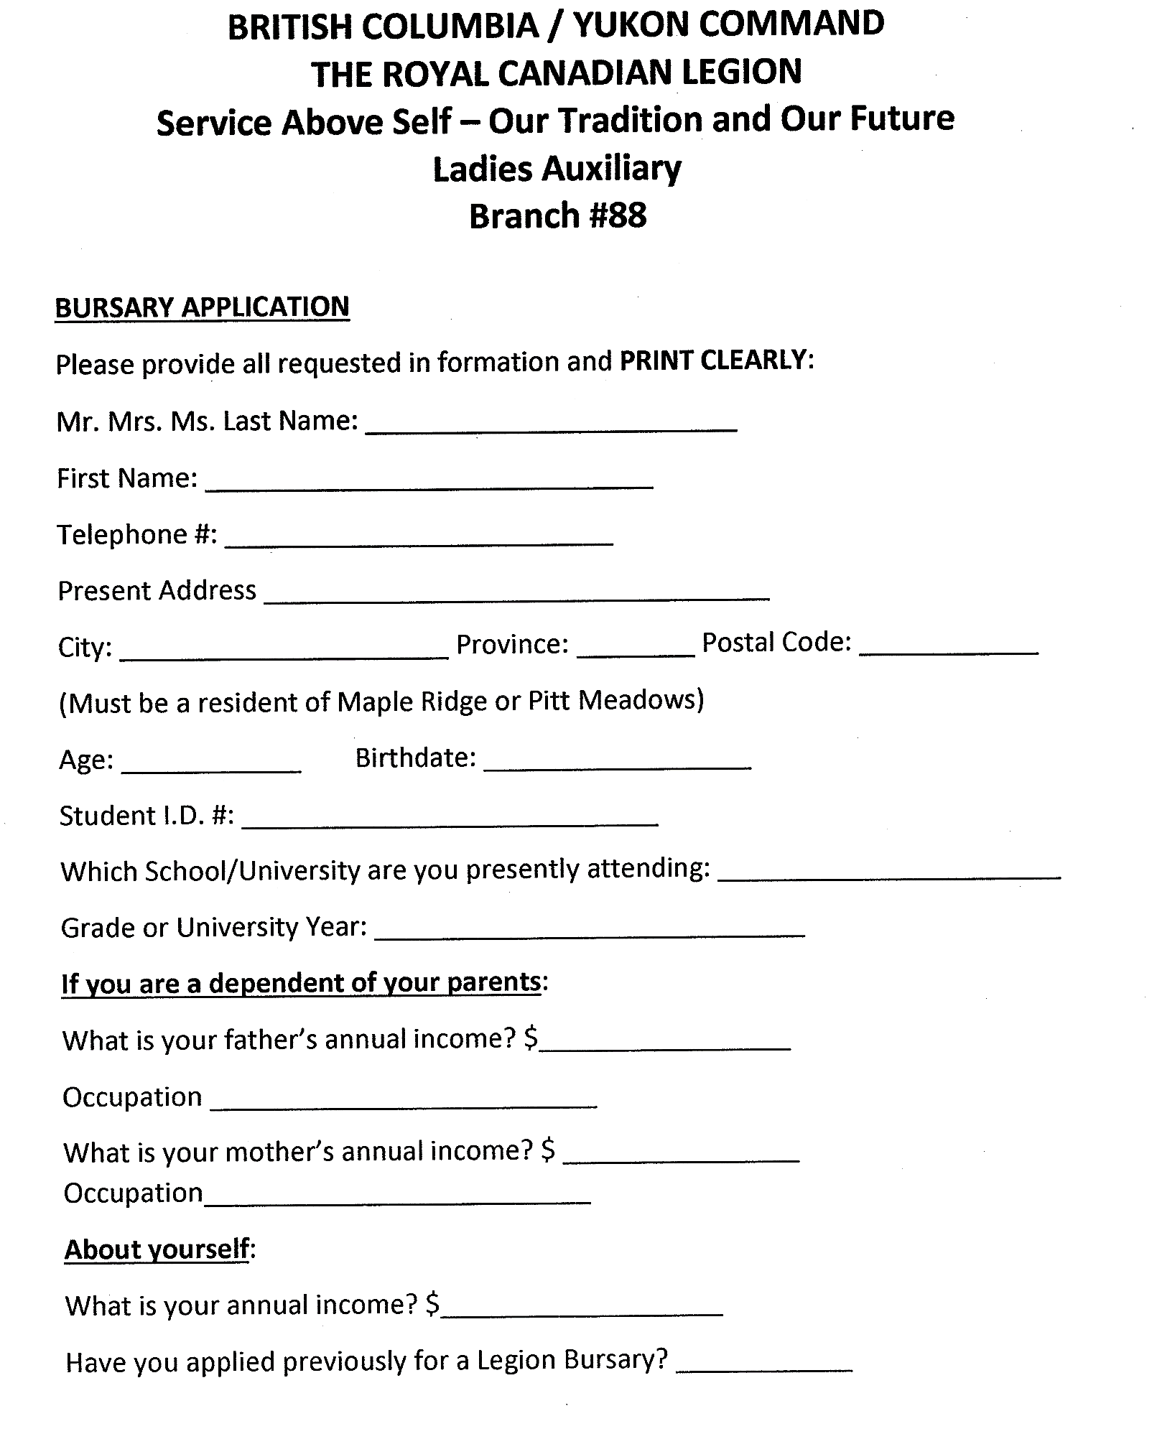

APPENDIX J

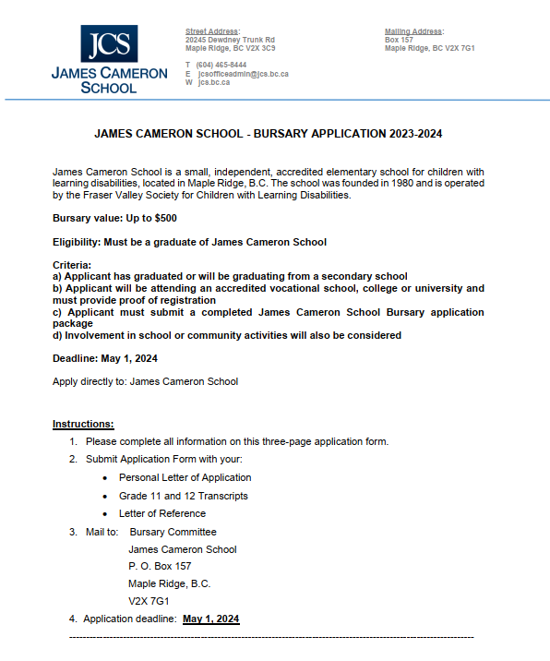

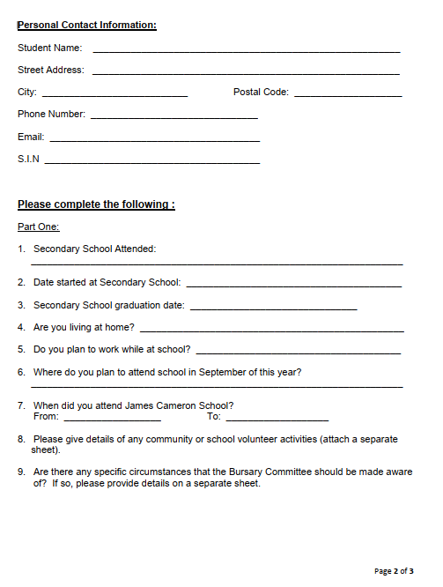

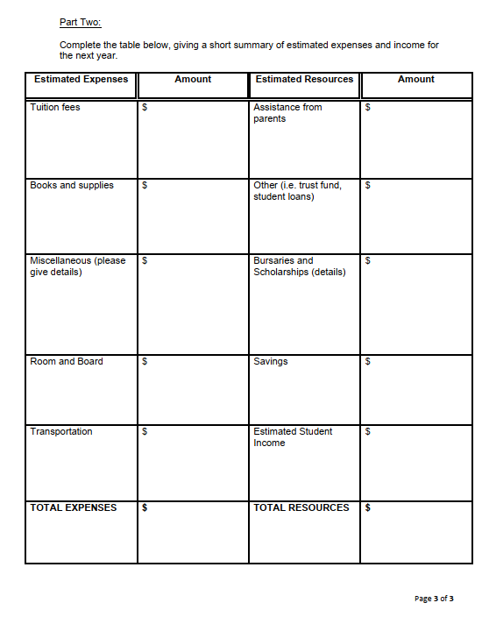
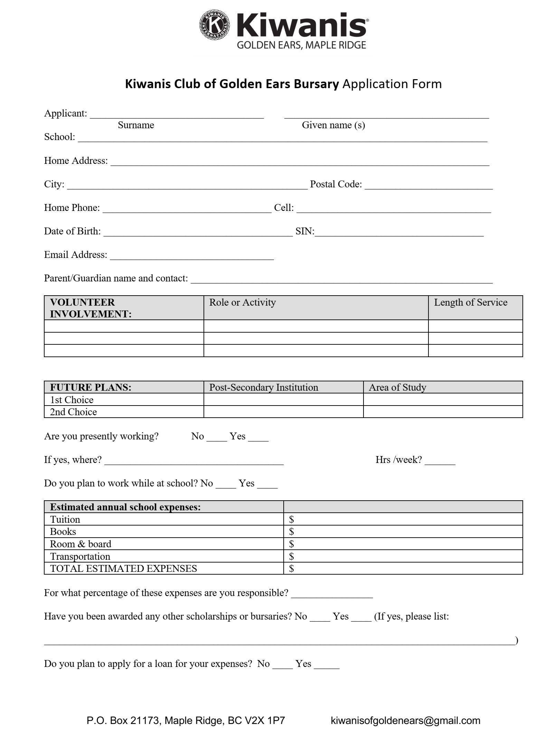
APPENDIX K

APPENDIX L

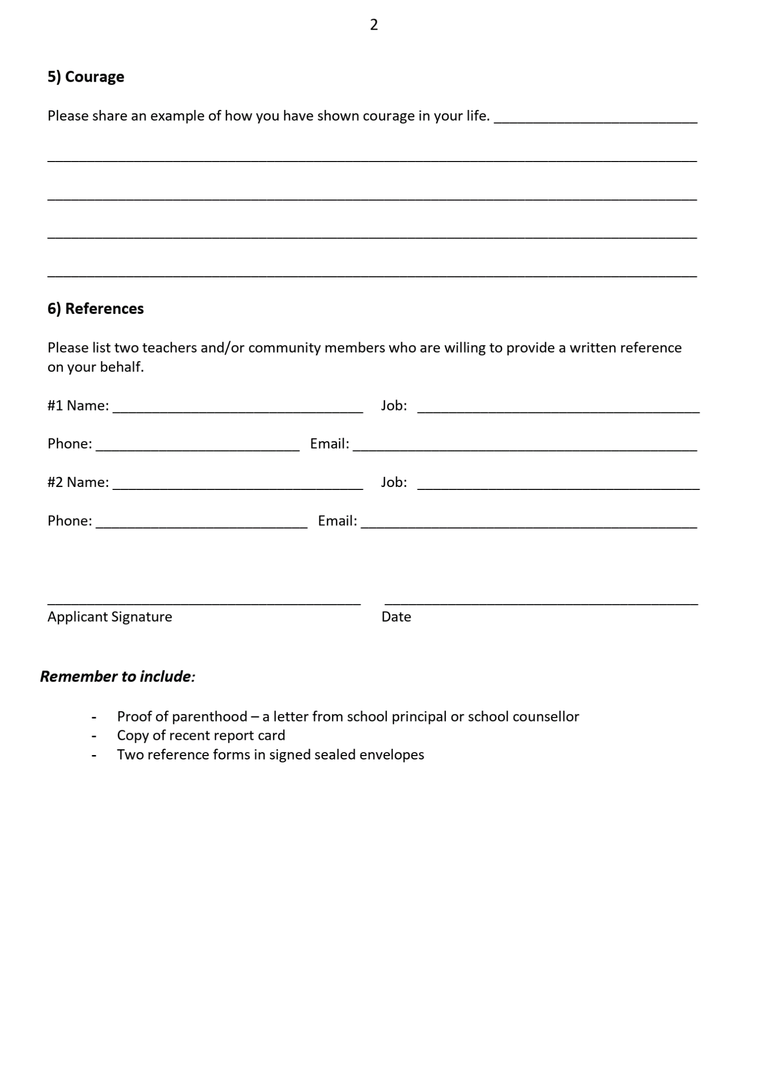
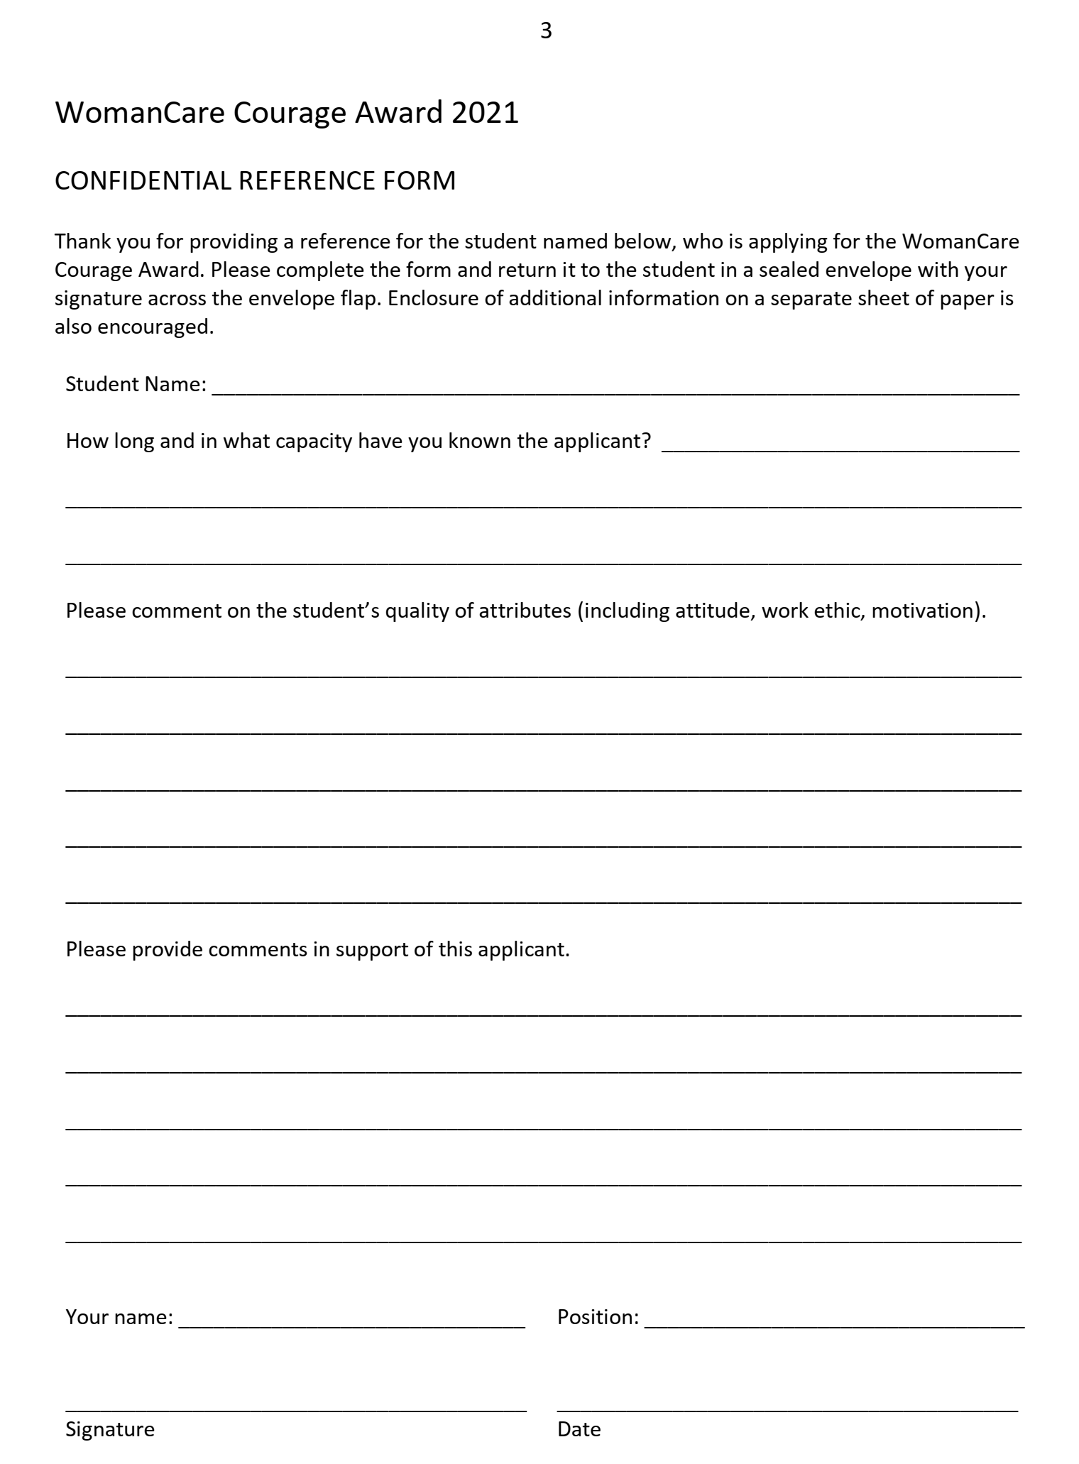

APPENDIX M

Gary and Nanette Lycan Scholarship Application

Additional Scholarship Information
The scholarship will cover the actual cost of tuition fees, up to $6,00 per academic year (as defined by the institution being attended) or $2,500 per semester for full time studies leading to an undergraduate degree in the sciences or a science-related field. The amount will be available each year for up to five years (or twelve semesters) leading to achievement of the student’s undergraduate degree. Student will need to maintain a minimum of 3.0 grade point average and continued enrolment in the sciences or science-related field for the following year. Funding will continue to be available on the same basis for up to three years of graduate studies. An annual progress report will need to be provided to donor.

Applicant Information

Student Name
Date of Birth
Address
Contact
(Phone and/or Email)
Confirm the following:
Canadian Citizen (check box)
Resident of Maple Ridge and/or Pitt Meadows for the last 3 years? (check box)

Future Plans

Name of Post-Secondary Institution Planned Area of Study
1st Choice
2nd Choice
3rd Choice

Required Attachments

- Transcript of School Marks for Grades 11 and 12
- Personal statement outlining your post-secondary academic goals and long-term career goals (recognizing changes may occur over time)
- Minimum of two (2) reference letters from teachers (1 Science or math teacher)

